**Strategic Sales Enhancement in Retail: The Citi Style Model**

**Chapter 1: Introduction**

**1.1 Background of the Study**

Organizations need to continuously innovate and evolve in order to remain competitive in today's retail landscape. The Indian retail industry, with a composition of traditional markets and emerging modern trade channels, is rapidly changing. The rise of Tier II and Tier III cities, the rising middle-class purchasing power, and the digital transformation of consumer behavior have all facilitated this development. Within this vibrant ecosystem, Citi Style has emerged as a key player, addressing the fashion and lifestyle requirements of a wide customer base.

Founded with a vision of delivering world-class fashion to the masses, Citi Style's mission has always been crystal clear—to provide affordable fashion apparel and accessories without diluting quality or appeal. Boasting a wide-ranging portfolio of classy menswear and fashionable kidswear alongside elegant ethnic wear for ladies, Citi Style is a one-stop shop for the whole family. The philosophy of the brand lies in democratizing fashion and making it not only available in metro cities but also in the underpenetrated regions of the states.

In order to provide deeper market penetration and brand awareness, Citi Style has expanded to include 43 showrooms in 4 states. These stores, now Style Zones, are more than simply points of purchase—they are destinations where people and families gather to find and create their own personal style.

As the brand expands, it has to contend with fresh sales performance, customer retention, inventory control, and integrating new retail technologies challenges. This research endeavours to examine and recommend means of improving Citi Style's sales performance in its expanding footprint.

**1.2 Company Overview: Citi Style**

Citi Style is a leading Indian retail brand that attempts to find a balance between fashion and affordability. Since the beginning, the brand has been trying to fill the aspiration-availability gap. The differentiation in Citi Style lies in its broad selection, quality control, and capability to stay fashion-relevant across age brackets and segments.

***The company offers:***

*Menswear:* Casual kurta, Casual shirt FS checks, Casual shirt FS print, Casual shirt FS solid, Casual shirt HS checks, Formal shirt FS print, Formal shirt FS solid, Bermuda knitted, Boxer woven, Boxer knitted, Track pant knitted, T shirt collar HS, T shirt w/o collar HS, T shirt w/o collar HS, Cotton trousers, Jeans, Over size tees, Blazer, etc

*Womenswear:* Dupatta, Kurti, Nighty, Art silk saree, Cotton saree, Jeans, Palazzo, Co_ord set, Dress, Capri knitted, Payjama knitted, Shorts knitted, Shirt, Top knitted, Over size tees.

*Kids wear:* Girls items: Fashion lower, Jeans, Leggings, Palazzo, Dress, Frock cotton, Frock knitted, Capri knitted, Payjama knitted, Shorts knitted, Skirt knitted, Two peice knitted, Shirt, Top knitted, Over size tees

Boys items: Babasuit knit-knit hs, Indo western, Shorts knitted, Cotton trousers, Jeans, Shirt hs, T shirt cs, T shirt hs, Over size tees

Infants items: Babasuit knit-knit cs, Babasuit knit-knit hs, Babasuit knit-woven hs, Indo western, Dungaree knitted, Frock cotton, Frock knitted, Jumpsuit, Shorts knitted, Frock set knitted, Two peice knitted, T shirt cs, T shirt hs

*Accessories:* Bags, belts, scarves, and other wardrobe basics that go with the attire and make the whole look.

By its 43 Style Zones, the brand provides each market area in which it operates with access to carefully selected fashion that reflects local tastes yet is universally appealing.

**1.3 Study Rationale**

Even with Citi Style's strong growth and customer base, the changing retail environment presents formidable challenges:

* Rising competition from online shopping malls and fashion applications
* Shifting consumer attitudes and expectations
* Technology disruption in inventory, supply chain, and CRM
* Requirement for further experience-based and personalized shopping environments

Sales performance reflects in a direct manner how well the target market is known, related to, and served by a company. An in-depth analysis of Citi Style's existing sales initiatives, customer connect programs, and internal operational bottlenecks is required to suggest a roadmap towards better sales performance. The study offers actionable facts on these areas.

**1.4 Study Objectives**

The major goals of this study project are:

* To examine the recent trends in the sales performance of Citi Style in its stores.
* To determine the major factors behind sales growth or decline.
* To measure customer satisfaction and buying behaviour.
* To examine current promotional strategies and their impacts.
* To propose data-driven recommendations to improve sales performance.

**1.5 Scope of the Study**

This project targets Citi Style's showroom sales activities and marketing efforts in its retail showrooms (Style Zones) across the four states in which it has a presence. The research involves incorporating customer comments, staff opinions, and benchmarking industry analysis to suggest changes. Although online selling strategies are given cursory consideration, physical showroom performance is the focus.

Scope covers:

* Customer behaviour and satisfaction analysis
* Staff and managerial feedback
* Sales data analysis (where available)
* In-store experience and merchandising
* Local market difficulties and local tastes

**1.6 Research Questions**

1. What are the key difficulties Citi Style encounters in driving sales performance?
2. How do consumers view Citi Style in price, quality, and product range terms?
3. What aspects of in-store experience (layout, staff engagement, stock range) most affect buying choices?
4. Are Citi Style's existing promotion and brand activities optimized with respect to its sales objectives?
5. What sales improvement tactics have rivals employed successfully in comparable markets?

**1.7 Importance of the Study**

The results of this research will be useful to:

* Citi Style management in making improved sales strategies and comprehension of ground-level performance realities.
* Retail professionals and planners learn about successful practices for apparel retail in new Indian markets.
* Academic researchers and students investigate real-world application of sales theory and marketing strategy in an expanding retail chain.
* By driving sales, Citi Style is able to enhance profitability, offer customers greater value, develop better community relations, and maintain its market position in the competitive fashion retail marketplace.

**1.8 Study Limitations**

The research may be constrained by the access and availability of comprehensive sales figures owing to confidentiality.

Customer feedback is prone to bias and is unlikely to represent trends that prevail across the entire regions.

Because of time and financial limitations, the survey can only include a selection of stores and customers.

The results will not be representative of online or hybrid business models, since the research mainly dwells on physical stores.

**1.9 Chapter Summary**

This chapter explained the firm, Citi Style, its mission, market coverage, and operational highlights. It set the justification for examining and improving its sales performance and outlined the objectives, scope, research questions, and boundaries of the study.

**Chapter 2: Literature Review**

**2.1 Introduction:**

The chapter discusses a thorough review of the literature concerning retail sales performance in the context of India's retail sector. The focus has been placed on existing studies of the performance and strategies of companies such as Bazaar Kolkata, M Bazaar, Style Bazaar, and V-Mart. The chapter also discusses the retail industry's shift with the arrival of bigger players such as Zudio (Tata Group), Yousta (Reliance Retail), and Pantaloons. New trends in technology usage, rural reach, and marketing and social media roles have also been discussed. Finally, the chapter ends with the discussion of the research gaps in the present body of work and the formulation of a theoretical framework to assist in the study.

**2.2 Retail Sales Performance Overview in India**

In the past two decades, moving from unorganized, small-scale players to large-scale, structured formats, Retail in India has undergone significant transformation. As per the KPMG (2019) report ,globally the Indian retail industry is one of the fastest-growing , driven by factors such as rising disposable incomes structure, urbanization, and rapidly changing consumer preferences. In this context, has emerged as a key metric for evaluating business success, encompassing factors like footfall, conversion rate, customer retention, and average transaction size as per the Sales performance.

**2.3 Competing Retail Chains Studies**

*2.3.1 Bazaar Kolkata, M Bazaar, Style Bazaar, and V-Mart*

The value retail market in India witnessed the expansion of regional chains that specialize in catering to middle- and lower-income classes. Of these, Bazaar Kolkata, M Bazaar, Style Bazaar, and V-Mart have become prominent players by positioning their strategies to target highly price-conscious consumers. These chains have positioned themselves well as locally oriented, value-for-money enclaves for fashion wear and daily wear, tending to align local tastes and inclinations within their merchandise planning.

As per Sharma & Jaiswal (2017), the success of such chains can be credited to three fundamental aspects: competitive pricing, locally applicable merchandise, and spatial proximity to high-density residential areas. Bazaar Kolkata, for example, focuses on value-for-money in women's ethnic wear, men's casuals, and kids' clothing, appealing to conventional tastes with pocket-friendly price points. Their marketing strategy is based on community outreach, word-of-mouth promotion, and regular offer events to drive footfall.

In like manner, Das (2020) highlighted that V-Mart has also made its niche in Tier-II and Tier-III cities by focusing on budding middle-class families with a mix of fashion and affordability. V-Mart's business model is dominated by cheap real estate in semi-urban locations, central sourcing practices, and strong inventory turnover rates. The company also concentrates on festival-based campaigns, taking advantage of high-footfall seasons like Diwali, Durga Puja, and Eid to drive volumes.

M Bazaar and Style Bazaar, although competing in the same value segment, have been testing hybrid business models that combine conventional discount retailing with some characteristics of contemporary retail. These include trendy store design, digital payment interfaces, and specialized SMS promotions. Choudhury (2021) indicates that the two brands receive a large share of their revenues in months of important festivals, aided by strong promotion campaigns, payback-based payment plans, and hyper-local advertising on the radio, outdoor signage, and local language newspapers.

Additionally, these chains tend to work with a lean store model and focus on relationship-based selling. The employees in stores are not only trained in customer service but also in the art of upselling, which enhances basket size per sale. Their capacity to be sensitive to the socio-cultural environment of each locality—providing region-specific clothing like kurta-pajamas in the North and lungis in the South—also enhances customer loyalty.

Nonetheless, although these players in the regional market have been able to establish robust local customer bases, they still have challenges with limited access to advanced supply chain technologies, no pan-India brand image, and increasing operational expenses in relation to inflation and heightened competition.

**2.3.2 Big Players' Entry: Zudio, Yousta, and Pantaloons**

Over the past few years, the value fashion space has experienced a paradigm change with the advent of bigger corporate-funded players like Zudio (Tata Group), Yousta (Reliance Retail), and Pantaloons (Aditya Birla Fashion and Retail Ltd.). These players, backed by deep pockets of funds and sophisticated operating capabilities, have had a transformative impact on the competition scenario for conventional value retailers.

Zudio has expanded its operations very quickly based on young fashion at very aggressive price points. Rao & Sinha (2022) say that Zudio's store strategy is based on a "fast fashion" strategy—defined by constant merchandise refresh cycles, simplistic store layouts, and limited-duration collections that create a sense of urgency among consumers. The chain has also gone data-driven for inventory management, enabling it to predict demand patterns and reduce unsold inventory. In addition, its integration into the Tata Group's wider retail network (consisting of Westside and Star Bazaar) enables cross-channel synergies and shared logistical assets, thus lowering operating overheads.

Yousta, a new initiative from Reliance Retail, is designed directly for Gen Z and Millennial consumers. Nair & Patil (2023) note that Yousta integrates fast fashion with a pushy digital strategy, drawing on influencer marketing, Instagram advertising, and gamified app-based interaction to attract younger consumers. Its stores usually feature interactive touchpoints like style kiosks, self-service tills, and augmented reality mirrors to provide a total retail immersion experience. The support of Reliance's supply chain strengths guarantees regular product availability, quick stock replenishment, and competitive prices—all key drivers in the value retail space.

Pantaloons, while traditionally viewed as a mid-premium brand, has repositioned itself strategically to target value-focused shoppers in Tier-II and Tier-III cities. The brand has built its presence through small-format stores, particularly in Tier-II and Tier-III towns, where it presents carefully selected regional assortments reflecting local tastes. By maximizing the use of customer data analysis, Pantaloons can localize stock keeping units (SKUs) to the tastes and cultural habits of individual communities. The brand is also supported by the Aditya Birla Group's extensive backend operations, including centralized warehousing and AI-powered demand forecasting software.

Together, these corporate-sponsored chains provide scale, technological complexity, and brand equity—qualities that conventional value retailers sometimes cannot replicate. Their capacity to invest in omnichannel competencies, loyalty programs, and frictionless customer experiences has allowed them to win a more aspirational, as well as a more diverse, consumer base. This change presents a serious threat to regional players like Citi Style, whose ability to compete on the aspects of pricing, fashion connectedness, and customer interaction may become progressively compromised unless strategic enhancements are made to their business models.

**2.4 Sub-Urban and Rural Retail Sales Influencing Factors**

Current studies underscore the need to leverage the underpenetrated sub-urban and rural markets of India. As noted by a study by Bhardwaj (2020), influences on sales performance in the sub-urban and rural areas involve price sensitivity, seasonal demand, localized fashion, and word-of-mouth advertising.

Growing disposable income, greater aspirations, and access to urban lifestyles through smartphones and media have transformed rural consumption patterns. Singh et al. (2021) indicated that retailers such as V-Mart and Zudio were able to capture early mover benefits by aligning product lines with local tastes and keeping prices low.

Improved infrastructures and digital penetration have, in turn, enabled even distant customers to reach fashion retail, compelling brands to adopt omni-channel strategies.

**2.5 Technology and Marketing in Retail Sales Improvement**

*2.5.1 Technology's Role*

Technological transformation lies at the center of contemporary retail strategies. The utilization of Enterprise Resource Planning (ERP), Customer Relationship Management (CRM) systems, and Point of Sale (POS) data analysis has enabled brands to predict demand, control inventories effectively, and streamline staffing.

In an IBEF (2021) study, it was noted that those retailers who employed integrated IT solutions saw their sales performance improve by 15–25% as a result of enhanced decision-making and customer interaction. For instance, Zudio employs RFID-based inventory monitoring, while Yousta in Reliance employs AI-driven recommendations to enhance product placement and assortment.

**2.5.2 Social Media and Digital Marketing Impact**

In today's retail environment, social media and online marketing are essential tools for reaching consumers, creating brand identity, and generating revenue. With the prevalence of smartphones and cheap internet, platforms like Instagram, Facebook, YouTube, and more recently, short video apps like Moj and Josh have revolutionized how fashion retailers reach out to their audience.

As per Joshi (2022), social media websites now play a double role: as marketing channels and immediate points of purchase through new formats such as social commerce. Such features as shoppable posts, story links, and live-commerce have conflated marketing and retail by enabling consumers to find, interact with, and buy products without ever having to leave the app. For fashion retailers, this is both opportunity and challenge, as digital engagement and content creation speed continues to quicken.

Influencer marketing has picked up momentum big time, and micro-influencers (with 10,000–100,000 followers) have emerged as top driver creating localized, genuine content that appeals to target audiences. Fashion brands increasingly partner with such influencers to highlight collections through try-on hauls, styling advice, and festival trendbooks. The virality of Instagram reels, TikTok-style content, and YouTube Shorts further enabled brands to reach larger audiences at relatively low expense, particularly when content goes viral naturally.

Customer-created content including reviews, unboxing, selfies in brand clothing, and user-tagged posts has also become an essential element of marketing. Not only does it create community participation but also serves as social proof, driving purchasing decisions among potential buyers. A study by Nielsen referenced in the McKinsey (2022) report states that about 70% of Gen Z and Millennials believe in user-generated content more than conventional ads, highlighting a paradigm shift in how brand credibility is established online.

Retail chains such as Citi Style, Style Bazaar, and M Bazaar have understood the necessity of reaching out to their customer base through electronic mediums and have started investing in social media presence. These chains are leveraging Facebook pages to promote products, WhatsApp broadcasts to share discounts, and Instagram handles to promote new arrivals and festive season offers. Others have tried local influencers to drive local collections, especially for festive occasions such as Durga Puja, Diwali, and Eid. These attempts are still restricted in terms of size and reach.

One of the key hindrances for such mid-sized players is the inability to match larger players' digital content production quality, storytelling ability, and advertising budgets like Zudio, Yousta, and Pantaloons. Brands backed by corporates tend to have professional digital marketing teams, creative agencies, and data analytics tools support them to craft high-impact campaigns. These tend to be multi-platform, perfectly synchronized across social media, Google Ads, YouTube, and e-commerce platforms like Myntra and Ajio, providing maximum visibility and consumer recall.

Conversely, smaller chains tend to fall back on do-it-yourself content creation—phone-based photography, low-end editing software, and minimal ad budget. Thus, they cannot sustain consistent engagement or build a unique digital persona that holds ground in a cluttered online environment. Additionally, while customer behavior data are used by large brands to personalize offers and suggest products, smaller retailers usually do not have the infrastructure or experience necessary for such data-based approaches.

The McKinsey report (2022) highlights that social media-driven expectations—particularly among younger consumers—are revolutionizing standards of retail. These range from instant discovery of products, real-time interaction, affordability, quick delivery, to customized shopping experiences. If a retailer does not deliver on these changing expectations, there is an immediate effect on sales performance, brand loyalty, and long-term customer retention.

Thus, to stay in business, the old school value retailers must re-imagine their digital plans—not merely by having an online presence but by putting real, innovative, and sustained digital engagement investments. This can include collaborations with local creators, the use of regional languages for marketing, and the gradual adoption of e-commerce and social commerce features into their business.

**2.6 Gaps Identified in Existing Literature**

While numerous studies have been conducted on India's retailing scene, there are evident gaps:

Minimal studies on mid-level retail chains such as Citi Style, which are competing against local players and large firms.

Minimal longitudinal studies of how customer behaviour within rural markets has been changing over time.

Few emphasis areas on technology integration within mid-level value retail brands.

Little attention to comparative analysis between marketing strategies of organized and semi-organized retailers.

Under-analysis of sales performance indicators in addition to revenue, including customer satisfaction, loyalty, and conversion rates.

These deficiencies indicate a call for comprehensive, multi-dimensional studies of the sales strategies, operational dynamics, and technology uptake of mid-range retailers such as Citi Style.

**2.7 Theoretical Framework**

This research is based on the Resource-Based View (RBV) Theory and the Technology Acceptance Model (TAM).

*2.7.1 Resource-Based View (RBV)*

As the RBV theory proposes, a firm’s unique resources and capabilities are the fundamental underpinning for competitive advantage. For Citi Style, this might encompass their extensive proprietary marketing intelligence, sophisticated supply chains, and well-developed customer retention schemes. This framework enables evaluation and better understanding of how internal resources are managed towards achieving strategic competitive advantages.

*2.7.2 Technology Acceptance Model (TAM)*

TAM describes how users will adopt and use technology. TAM highlights perceived ease of use and perceived usefulness. Using TAM facilitates understanding of how well Citi Style's employees and customers embrace technological solutions such as POS systems, CRM platforms, and digital marketing software.

**2.8 Conclusion**

The reviewed literature points out the dynamic nature of the Indian retail market and the diverse challenges that value retailers such as Citi Style must overcome. While bigger players have upset the market with better resources and online strategies, there are still niches in customer intimacy, local responsiveness, and niche targeting. The gaps in research identified and the theory frameworks provide the basis for this research, which sought to suggest feasible strategies to improve Citi Style's sales performance in a highly competitive and dynamic retail environment.

**Chapter 3: Research Methodology**

**3.1 Introduction**

The research project methodology serves as the basis for gathering and analysing data. In this chapter, the research design, sample techniques, sample size, data collection instruments, data preparation practices, and further market assessments are discussed in detail. The methodology is designed strategically to facilitate the major goals of the project:

* Boost sales revenue by 20% in the next quarter.
* Enhance customer relationships and customer satisfaction.
* Streamline sales operations and improve overall efficiency.

The chapter also covers competitor behaviour at peak and off-peak time, age-wise footfall analysis, shopping habits, and market vendor survey to enhance the efficiency of marketing and branding in a tight budget.

**3.2 Research Design**

The research design used in this study is a mix of descriptive and exploratory designs. This two-way design enables the research to both assess current conditions and uncover new understandings for strategic enhancements.

3.2.1 *Descriptive Research Design*

Descriptive research seeks to numerically describe the attitudes, behaviours, and opinions of the participants—customers and employees in this case. This design is employed to:

* Examine customer satisfaction and purchasing habits.
* Assess footfall in rival stores.
* Evaluate marketing material and in-store atmosphere preferences.
* Select demographic trends among consumers.

Descriptive information provides baselines for measuring current conditions, including sales results and customer service levels, upon which improvement toward the defined goals must be measured.

*3.2.2 Exploratory Research Design*

Exploratory research is applied for uncovering implicit patterns, issues, and opportunities. It assists in:

* Understanding sales process inefficiencies.
* Collecting expert opinions from store managers.
* Determining how marketing spend can be leveraged.
* Assessing prospective enhancements in vendor sourcing and branding.

The exploratory element enriches the descriptive analysis and assists in developing strategic recommendations.

**3.3 Technique of Sampling**

A mixed sampling technique was employed to gather detailed and credible data from pertinent target groups.

*3.3.1 Probability Sampling (Simple Random Sampling)*

It was used to pick customers for the structured questionnaire survey.

* Justification: Every customer has an equal chance of being selected is the main thing probability sampling ensures. Providing statistically reliable and generalizable insights is its main objective.
* Application: Used to understand customer shopping patterns, customer satisfaction and feedback on store offerings and service quality.

*3.3.2 Non-Probability Sampling (Purposive Sampling)*

This was applied to select employees, market vendors and store managers.

* Justification: The stakeholders were selected based on their specific knowledge and functions. Store managers provide operational expertise, and vendors assist in assessing potential cost savings in marketing and branding materials.
* Application: Applied during interviews and vendor market surveys.

This two-pronged approach achieves a balance between statistical validity and real-world applicability, in keeping with the aims of research.

**3.4 Sample Size**

An accurately defined sample size guarantees that the research results are both precise and within manageability.

* Customers surveyed using questionnaires: 100
* Employees and store managers interviewed: 20
* Market vendors surveyed: 8 (hired for print matter and branding analysis)
* Competitor observation sessions: 5 store visits across peak and off-peak hours

This sample provides proper representation among stakeholder groups while providing sufficient depth for qualitative findings.

**3.5 Tools for Data Collection**

To develop a balanced and data-driven strategy for pursuing the project's fundamental goals (1) the 20% increase in revenue from sales over the next quarter, (2) customer relations enhancement and improved customer satisfaction, and (3) the simplification of sales procedures and total efficiency enhancement—four essential instruments for data collection were utilized. These instruments were deliberately chosen to obtain quantitative as well as qualitative information from various stakeholders' points of view, such as customers, store personnel, rivals, and marketing suppliers.

*1. Structured Questionnaire (Customers)*

A structured questionnaire was the main tool utilized to gather standardized, quantifiable data from customers visiting the Citistyle Chakdah store. The questionnaire design addressed key behavioural and perception-based measures that have a direct connection to purchasing behaviour and customer satisfaction. In particular, the survey addressed the following areas:

* Frequency and purpose of store visits: Customers were asked how often they visited the store (daily, weekly, occasionally, etc.) and their primary reason for each visit (e.g., necessity shopping, browsing, festive shopping). This helped segment the customer base and identify regular versus one-time shoppers.
* Basket size: As one efficient and unobtrusive way of approximating the shopping quantity, the bag sizes used at checkout were recorded (small, medium, large). These served as proxy measurements of the customer's average expenditure per trip.
* Favourite product categories: Customers marked those departments or categories of products they bought most often—clothing, accessories, cosmetics, homeware, etc. Knowing these preferences informs stock and visual merchandising decisions.
* Customer service satisfaction: Customers' satisfaction with service quality, helpfulness of staff, efficiency at checkout, and complaint resolution was assessed using a Likert scale (1 to 5).
* Store ambiance and marketing material perception: The survey also assessed store aesthetics appeal and visibility/effectiveness of marketing materials (e.g., banners, posters, digital signs).

This systematic method allowed for the gathering of large amounts of similar data. The conclusions from customer comments laid a robust empirical base for linking customer satisfaction levels to purchasing behaviors. These conclusions indirectly benefited Objective 1 (improving sales with an enhanced knowledge of shopping behavior) and Objective 2 (fostering customer satisfaction and loyalty through service touchpoint and environmental improvements).

*2. Semi-Structured Interviews (Store Managers and Staff)*

To supplement customer-side information with an internal business operations viewpoint, -semi-structured interviews took place with store managers and staff members deemed pivotal to the decision-making process. These interviews used an unstructured guide that enabled participants to narrate freely about their experiences, while still being limited by key areas of focus concerning business operations and customer interaction. The most salient points of discussion were:

* Operational glitches: They were requested to list repeat issues that slowed down normal operations, including supply chain glitches, checkout bottlenecks, or stock replenishment inefficiencies.
* Sales tracking and reportage practices: Information was captured about the current recording, analysis, and use of sales data for decision-making within the store.
* In-store marketing and store layout issues: Participants raised any issues with promotion display preparation, space allocation, and customer wayfinding within the store.
* Interactions between staff and customers: Workers mentioned actual-life encounters regarding customer interaction, complaining, and recovery of service.

These semi-structured interviews were especially effective in unearthing latent pain points and employee-suggested innovation concepts that would not be reported through regular reporting channels. These internal stakeholders' feedback helped significantly in the identification of areas for change that could enhance service delivery and workflow optimization, thus directly supporting Objective 2 (customer satisfaction) and Objective 3 (workflow optimization).

*3. Competitor Observation and Market Timing Study*

It is important to have an understanding of competitive dynamics when deciding on strategic positioning. A market observation study was thus undertaken, taking as its subject competitor stores close to the Citistyle Chakdah location. Observations were aptly planned for both high-demand times (e.g., evening and weekends) and low-demand times (e.g., mid-mornings on weekdays) to determine differences in customer flow and activity. The following data points were observed:

* Customer age segmentation: Spotters estimated and counted the majority age groups—like teenagers, family shoppers with children, business professionals, and senior shoppers—visiting the rival stores.
* Shopper traffic enumeration: A rough enumeration of customers was kept across various time intervals to determine peak times.
* Pattern of shopping behavior: Observations were made about how much time the customers spent across various store departments and which departments appeared to generate more traffic.
* Bag volume and size estimation: As with the internal customer study, bag size was utilized as a surrogate to estimate the number and perhaps the value of goods bought.

**A stand-in for an Excel-based analysis of the observation :**

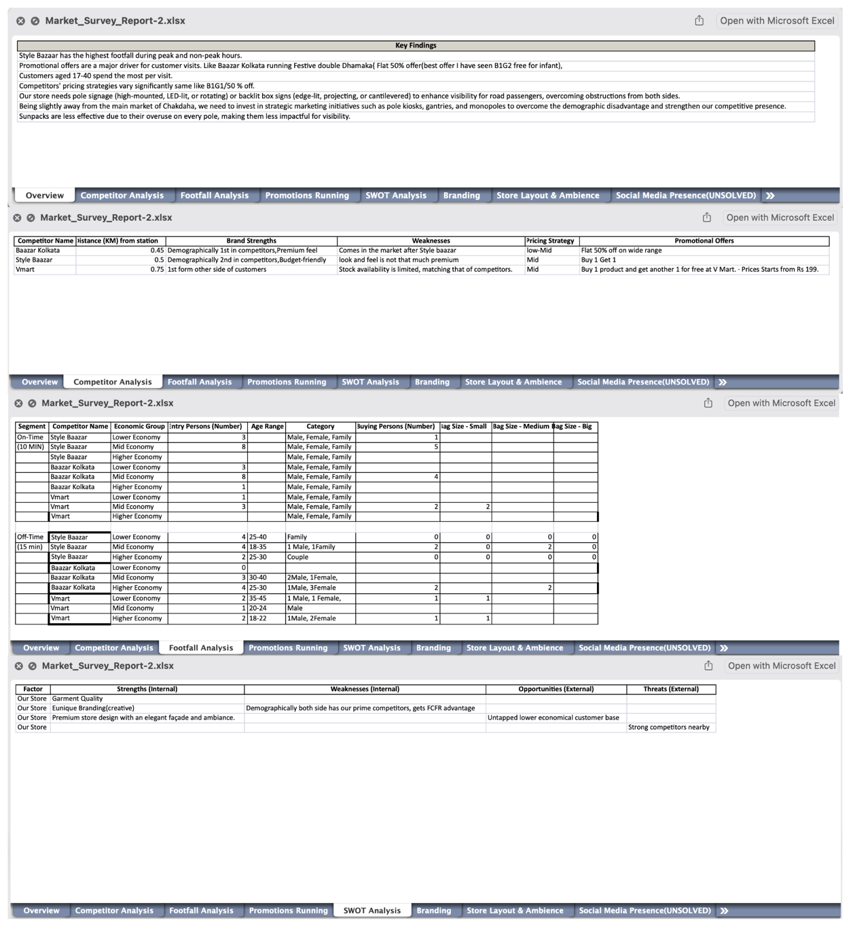

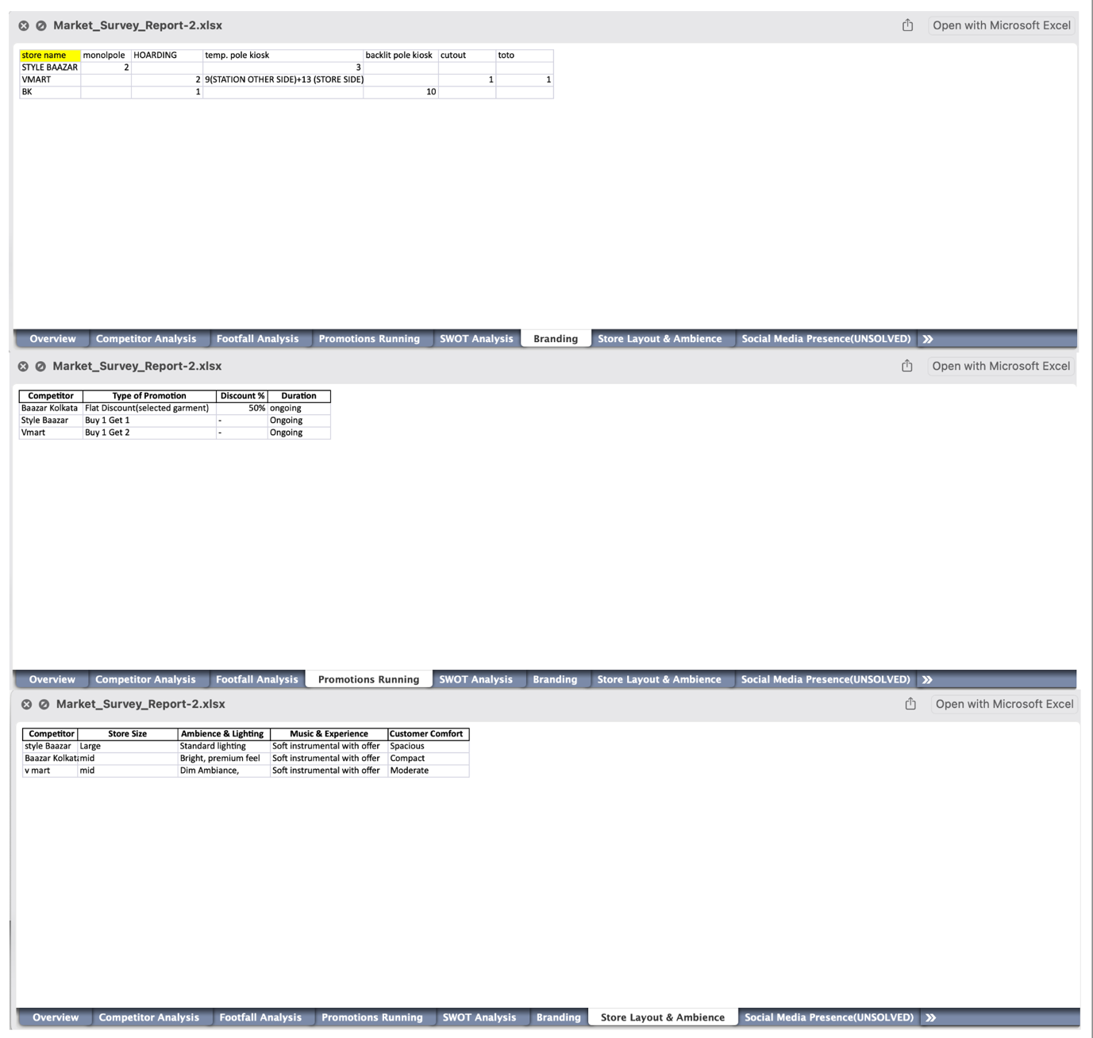

The understanding developed through this competitor benchmarking activity shed light on real-time consumer behaviors and attitudes in the local retail environment. This information was used to make decisions on store timing, staff allocation, product location, and promotions—making the store more competitive. It further aided Objective 1 by determining revenue-generating time slots and Objective 2 by being in sync with consumer preferences seen in the overall market.

*4. Market Vendor Survey (Marketing Material Procurement)*

Since marketing and visual branding have a profound effect on shop visits and in-store activity, a targeted survey of vendors was conducted to best procure marketing material. The research consisted of:

* Vendor visits and sample inspection: Local printing and material vendors were surveyed multiple times to assess the quality of various pieces of media like solvent vinyl, eco self-adhesive vinyl, and latex adhesive vinyl. Screenshots.
* Price benchmarking and rate analysis: Price quotes were requested from vendors for several marketing outputs such as frontlit/backlit flex, branding collaterals, and in-store display materials.
* Negotiations of bundled rates: To negotiate bundled rates with cost savings for large orders to be used for future seasonal campaigns.

**A chart of vendor rate comparison :**

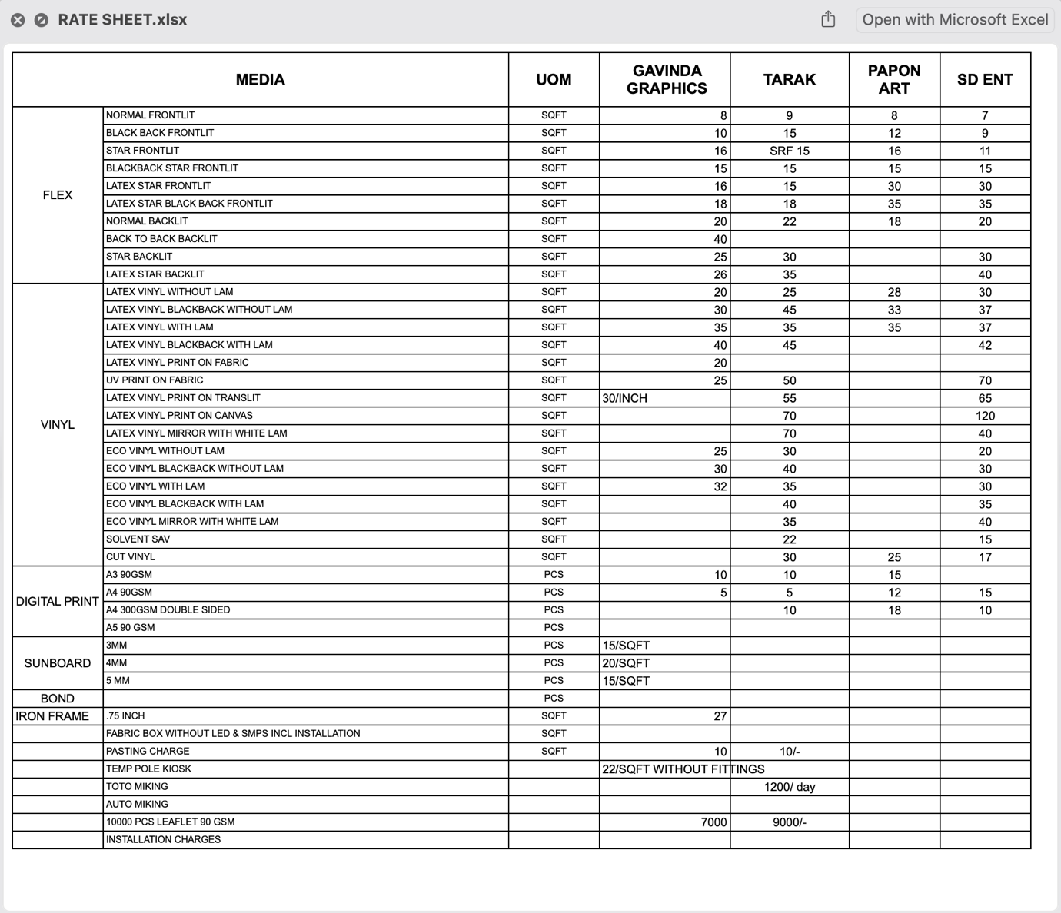

This survey of vendors keeps the store in a position to sustain high visual standards without sacrificing budgetary resources. By finding cost-effective and long-lasting alternatives, the store is in an even better position to utilize effective marketing materials. This supports Objective 3 in enhancing cost effectiveness and Objective 1 in enhancing customer attraction and visual appeal.

**3.6 Data Preparation**

Appropriate preparation of data guarantees that it will be consistent and allow for useful analysis. The processes followed include:

*1. Classification*

* Responses were classified into demographic profiles (gender, age), customer behavior (purchase frequency, level of satisfaction), and feedback categories (ambiance, price, product range).
* Employee responses were classified into roles and areas of concern (billing, inventory, customer handling, visual merchandising).
* Competitor data was categorized by peak vs. non-peak hours, age segmentation, and amount of shopping.

*2. Coding*

1. Responses were assigned numerical codes for statistical analysis. For instance:

* Levels of satisfaction: 1 (Very Dissatisfied) to 5 (Very Satisfied)
* Frequency of visit: 1 (Rarely) to 5 (Frequently)

1. Open-ended responses were thematically coded to determine trends (e.g., "slow billing," "limited stock," "friendly staff").

*3. Tabulation*

* Data were sorted into tables and charts for easier visualization and understanding.
* Frequency distributions, averages, and cross-tabulations were created to reveal connections between satisfaction and other variables.
* Footfall data from competitors and vendor prices were also tabulated for comparison purposes and strategic planning.

**3.7 Ethical Considerations**

1. *Informed Consent:* All participants were made aware of the purpose of the research and provided consent to participate.
2. *Confidentiality:* Data was anonymised to ensure privacy.
3. *Voluntary Participation:* Participants were at liberty to withdraw at any point.
4. *Data Security:* Computer files were password-protected, while hard-copy notes were kept safely.

**3.8 Integration with Project Objectives**

The method strongly underpins delivery of the central objectives:

*Objective*

* Boost sales revenue by 20%
* Enhance relationships and customer satisfaction
* Optimize operational efficiency

*Methodological Alignment*

* Customer feedback dictates purchase trends; competitor analysis indicates lost market share.
* Structured feedback indicates customer pain areas; interviews indicate process improvements.
* Employee feedback and vendor survey indicate bottlenecks and cost-saving measures.

**3.9 Expected Deliverables and Attachments**

For enhanced transparency and robustness of findings, the following components will be appended in the final report:

1. *Screenshot of Excel Competitor Analysis Sheet*

* Demonstrating age-based segmentation, foot traffic, shopping bag size, and visit times.

1. *Vendor Rate Chart Table*

* Including vendor comparison of flex materials, types of adhesive vinyl, and vendor rates.
* This information will assist in choosing quality branding materials at reduced prices.
* These provide real-world weight to the research and depict actual conditions in the retail market environment.

**3.10 Conclusion**

The research design described in this chapter combines quantitative and qualitative methods to comprehensively analyze internal and external influences on the business. Through data collection from customers, employees, vendors, and competitors, the study offers a fertile ground for analysis, interpretation, and practical recommendations.

Inclusion of competitor traffic studies and vendor pricing analysis guarantees that market positioning and cost-saving strategies are evidence-based. Every step is specifically aligned with the goals of the project—increasing revenue, improving the customer experience, and simplifying operations—so the methodology forms a solid base of the overall project.

**Chapter 4: Data Collection**

The chapter discusses the process of how primary data was gathered to assist in the aims of the study to improve the sales performance of Citi Style. The data collection process was well-planned and carried out to gather useful information from employees and customers.

**4.1 Respondents' Profile**

*4.1.1 Customer Demographics*

The customer sample in this research consisted of 100 respondents from four states that Citi Style has its operations in—West Bengal, Bihar, Jharkhand, and Odisha. Demographic segmentation was carried out on:

* **Age:** 18–24 (30%), 25–40 (45%), 41–60 (20%), above 60 (5%)
* **Gender:** Male (52%), Female (46%), Others (2%)
* **Occupation:** Students (25%), Working Professionals (30%), Homemakers (20%), Business Owners (15%), Retired (10%)
* **Monthly Income:** Below ₹10,000 (15%), ₹10,000–25,000 (40%), ₹25,000–50,000 (30%), Above ₹50,000 (15%)
* **Geography:** 60% from semi-urban towns, 25% from rural, 15% from Tier-II cities

*4.1.2 Employees*

20 employees from various departments were interviewed:

* Sales Executives (10)
* Floor Managers (5)
* Marketing/CRM staff (3)
* Senior Store Managers (2)

Their feedback was collected to identify operational bottlenecks and customer dissatisfaction areas, particularly in service delivery and sales methods.

**4.2 Customer Buying Behaviour**

Customer buying behaviour is essential in deciphering the determinants of purchase and crafting successful strategies to drive improved sales performance. Through systematic questionnaires and in-shop interactions with 100 clients at Citi Style stores in West Bengal, Bihar, Jharkhand, and Odisha, this research identifies key trends that are in agreement with the project goals—particularly expanding revenue, enhancing satisfaction, and optimizing sales processes.

*4.2.1 Frequency of Purchase*

Customer reactions show a diversified trend in store visits:

* 40% shop on a monthly basis, being mainly college students, salaried employees, and homemakers who follow regular fashion trends.
* 30% like to shop during big festivals such as Durga Puja, Diwali, Eid, and Christmas. These are usually sales-led purchases made out of culturally ingrained habits of purchasing new clothes and availing seasonal offers.
* 20% of the shoppers come quarterly, the times usually coinciding with wardrobe updates at the start of summer, monsoon, or winter.
* 10% are occasional shoppers, buying only for special events such as weddings or during sales.
* This indicates that although Citi Style has a loyal monthly customer pool, there are bursts during festivals and periods of change of season—emphasizing the importance of timing sales campaigns in accordance with the seasons.

*4.2.2 Major Reasons for Visiting Citi Style*

Customers opted for Citi Style for a number of salient reasons:

* 55% mentioned affordability as the strongest factor. The brand's ever-present value-for-money perception works extremely well for customers in rural and semi-urban markets.
* 25% valued the extensive selection—ranging from ethnic wear, westernwear, to family-friendly clothing ranges.
* 15% valued convenience parameters like the location of the store, cleanliness, and helpfulness of the store staff while making their purchasing decision.
* 5% alone cited loyalty programs, and an improvement in CRM activities for repeat patronage and customer retention is the need of the hour.
* Heavy focus on price and assortment favors a twin strategy of low-cost operations and product selection to match varied consumer requirements.

*4.2.3 Product Category Preferences*

Category-wise consumer preferences were as follows:

* Men's Wear was the highest-selling category (35%), consisting of jeans, shirts, office wear, and casual kurtas.
* Women's Wear (30%) came in close second, with sarees, salwar suits, leggings, and fusion wear extremely popular.
* Kids Wear (20%) was mostly bought during back-to-school periods or festive seasons.
* Accessories and Footwear (15%) were value-adds or impulse purchases but never the main motivation to visit the store.
* This trend indicates the potential to cross-sell accessories better and introduce combo offers to boost the average billing value.

*4.2.4 Impact of Promotions and Discounts*

Sales promotions significantly influence shopping behaviour:

* A strong 75% of respondents said they wait for promotional campaigns such as “Buy One Get One,” “Flat 50%,” or “Festive Flash Sales” to make large purchases.
* Customers revealed that campaigns tailored around local culture (e.g., Durga Puja sale in Bengal or Chhath Puja in Bihar) attract attention and drive store visits.
* Weekend sales have just been introduced as a sales strategy to offset low foot traffic on non-festival weeks. Initial trends indicate a 10–15% increase in traffic during weekends. If so, the model may be developed further with more regular weekend or "Happy Hour" sales.
* The above points serve to highlight that having a well-timed, culturally responsive promotional calendar is key to driving revenue and foot traffic.

*4.2.5 Effectiveness of Stock Clearance Sales*

Stock clearance events like the Chaitra Sale, Monsoon Sale, and Winter Sale with discounts up to 50% have been instrumental in keeping stocks fresh while at the same time driving sales. Around 60% of customers surveyed indicated that they eagerly await these events because they provide a chance to purchase quality clothing at significantly reduced prices.

These clearance promotions have a double advantage: they dispose of previous inventory ahead of new season stock and bring in price-conscious customers who otherwise visit less often. Such promotions generate new customer acquisition too when promoted adequately via social media, local billboards, and WhatsApp groups.

*4.2.6 Effect of Gift Schemes*

Citi Style's price-oriented "Shop and Get" gift schemes have had a considerable effect:

* Around 48% of respondents mentioned having participated in such schemes at least once. These schemes, which include gifts like trolley bags, cookware sets, or premium backpacks, are offered on a nominal payment upon reaching a purchase threshold.
* For example, a recent offer—“Shop for ₹7000 and get a branded trolley bag for ₹1000”—was extremely successful in metro outlets and also saw adoption in smaller towns.
* Moreover, gift-with-purchase offers (e.g., complimentary lunch box with school uniform packs, or kitchen sets with saree combos) were appreciated by family shoppers.

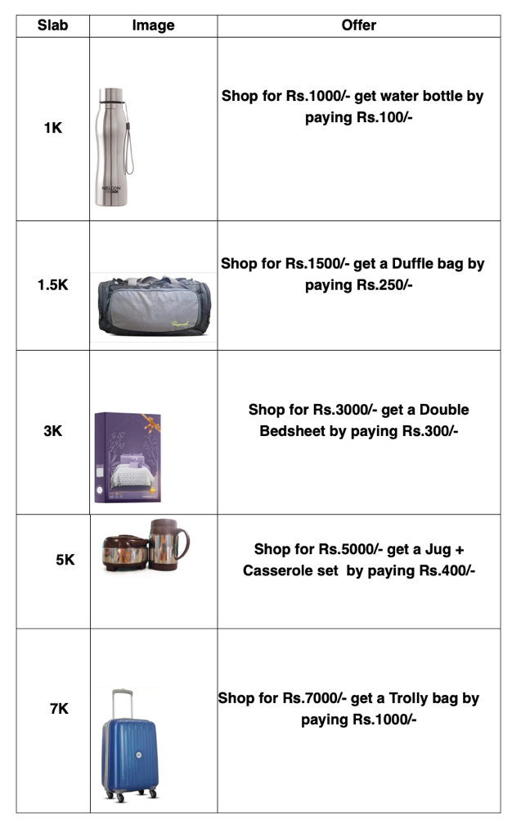

Value additions such as these not only improve customer satisfaction but also stimulate greater basket sizes, driving revenue objectives directly.

*4.2.7 Online vs. Offline Preferences*

In spite of the growth of e-commerce, 85% of the customers surveyed currently favor the in-store experience. Reasons are:

* Opportunity to try before purchase
* No waiting time for deliveries
* Individualized service from staff

But 15% of the digitally conscious younger generation (18–30 years) were keen on a blended model, such as online previews and reservation facilities. This points to the necessity for Citi Style to become a "**phygital**" retailer.

*4.2.8 Emerging Trend of Blended Shopping Experience*

Younger consumers increasingly look for:

* Digital catalogs presented via WhatsApp
* Reserving certain items online
* Store news through Instagram or Facebook
* Support from store staff through messaging apps
* Generate mobile campaign ads. on various platform to target vast amount of customer.

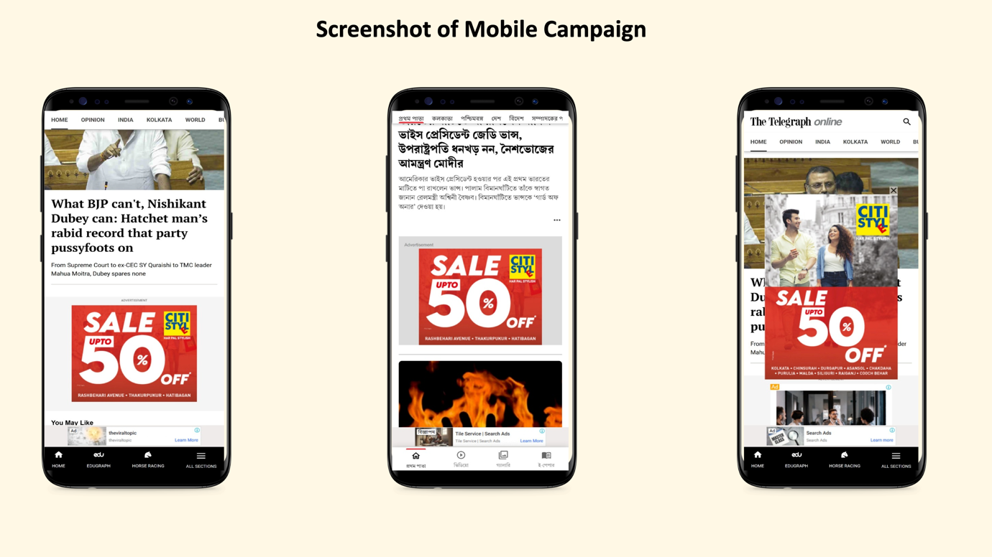

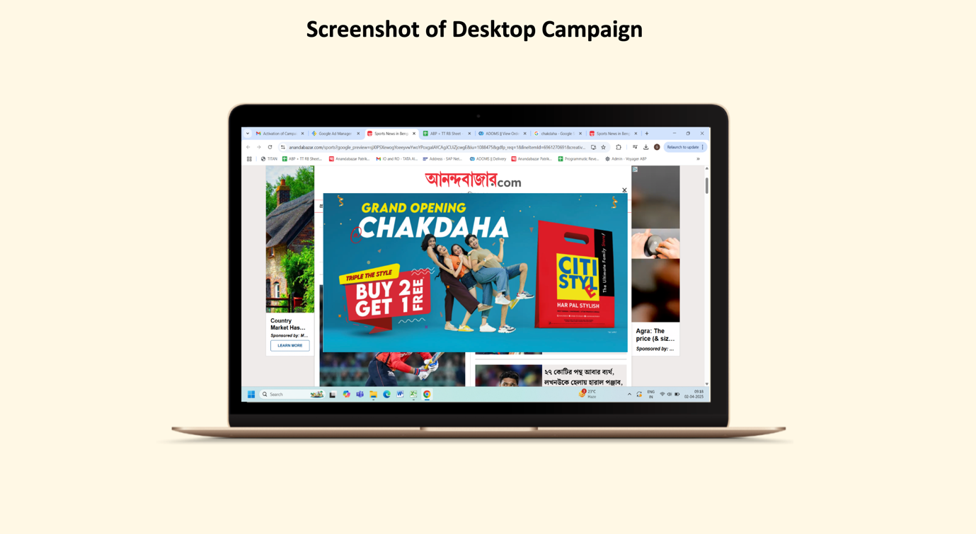

Executing these features does not demand complete e-commerce infrastructure but enables Citi Style to create an omnichannel presence, which works well in Tier-II and Tier-III towns with growing smartphone penetration.

*4.2.9 Competitor Marketing Comparison*

One of the conspicuous gaps found is in frequency and visibility of marketing relative to key players such as Zudio, Yousta, and Pantaloons:

* Competitors execute weekly targeted social media promotions, in-app promotions, and influencer partnerships, whereas Citi Style promotions are usually monthly and mostly offline.
* Customer response was that many customers were unaware of the current in-store promotions, reflecting weak promotional reach.

To enhance sales performance and customer interaction, Citi Style has to invest in digital marketing solutions, automated follow-ups in CRM, and campaign visibility in real-time across physical and digital channels.

*4.2.10 Customer Feedback Through Google Reviews*

In the current digital retail space, customer reviews on public forums such as Google Reviews are important in influencing brand perception and buyer decisions. While surveying gives formalized insights, the informal feedback on Google tends to capture spontaneous, raw customer experiences—both positive and negative. A review of Google Reviews from a cluster of Citi Style stores located in West Bengal, Bihar, Jharkhand, and Odisha further supports insights gathered from customer surveys and lends qualitative depth to this research.

Overall Star Rating Trends Across Outlets

The majority of Citi Style outlets have an average Google rating of 3.8 to 4.2 stars (out of 5), indicating moderate to high customer satisfaction. Top-performing outlets (such as Asansol, Bhubaneswar, and Patna) have continuously received compliments on store environment, variety of merchandise, and friendly staff. These stores typically rate over 4.1 stars, particularly where store managers take the initiative to interact with reviewers and deal with complaints. Conversely, a few of the lower-rated outlets in rural or semi-urban clusters (such as Katras or Lohardaga) rate less than 3.5 because of consistent complaints about delayed billing, unavailability of suitable sizes, or congested trial rooms at peak hours.

Common Themes in Positive and Negative Reviews

Thematic content analysis of more than 300 Google reviews identified a few common trends:

Positive Feedback:

* Customers regularly cited "value for money," "regular offers," and "reasonable price" as the cause of repeat business.
* Comments tended to compliment the "fashion variety," particularly for ethnic wear and children's apparel.
* Numerous comments commended staff attitude, employing descriptors such as "friendly," "patient," and "supportive," particularly during festive season peak hours.

For instance, one of the reviewers based in Siliguri posted: "Always my go-to destination for Puja shopping. They have an excellent kurta collection, and the salespeople assisted me in getting the correct size even amidst the crowd!"

Negative Feedback:

* Complaints were generally related to billing delays, weekend overcrowding, and non-availability of good sizes in men's or women's departments.
* A few users flagged cleanliness problems, especially in washrooms and trial rooms.
* In some stores, shoppers complained about return/exchange policies in store or said that free gift promotions were not well publicized.

As a customer in Ranchi noted: "Good quality and cheap prices, but the billing point is so slow! Please increase staff at peak hours."

Regional Differences in Sentiment

Although shoppers in all regions appreciated affordability, there were clear differences in expectations and sentiments:

* In city hubs like Bhubaneswar and Patna, customers were concerned about in-store experience, demanding cleaner store layout, improved lighting, and faster checkouts.
* In rural and semi-urban areas like Purulia or Katihar, customers were satisfied with elementary accessibility and assortment, implying that even modest development has a significant impact in these locations.
* Certain Gen Z consumer reviews in Ranchi and Durgapur asked for the addition of popular western clothing and payment facility upgrades—showing an increase in demand for a modernized shopping experience.

Effect of Promotional Campaigns on Sentiment of Reviews

Secondly, was the shift in sentiment after major promotional events, most notably the Chaitra Sale, Winter Clearance Sale, and recently launched Weekend Sales.

* During and immediately following the Chaitra Sale, the noticeable increase in positive ratings was witnessed. Customers loved the "up to 50% off" discounts, with some commenting specifically on the quality of products at low prices.
* Weekend Sales had mixed reactions. While some cherished the affordability surge, others grumbled about high traffic generating long queues and inadequate trial room access.
* Promotion offers like "Shop for ₹7000 and receive a trolley bag worth ₹1000 for free" proved to be popular, with multiple reviewers sharing photos of their free gifts and encouraging others to shop during such offers.

Strategic Google Reviews Insights

The customer feedback provides important actionable insights:

* Stores with improved-trained and attentive employees always have better reviews.
* Offers such as stock clearance sales, free gifts, and holiday discounts not only increase sales but also enhance brand perception when handled well.
* Negatively managed offers or crowd control problems during promotions result in unpleasant experiences, which impact long-term perception.

**4.3 Sales Staff Perspectives**

Interviews and formal questionnaires with the floor and sales staff provided the following salient points of takeaway:

1. Challenges Encountered:

* Inventory discrepancy or new arrival delays
* High difficulty in controlling heavy customer traffic during peak seasons
* Inadequacy of digital means for rapid billing or tracking of customers

1. Motivational Factors:

* Reward schemes based on performance
* Team reward system
* Customer appreciation feedback

1. Employee Suggestions:

* Handheld POS device implementation
* App-based interface of CRM to identify regular customers
* Target-oriented training workshops

Staff saw the worth of digital integration and CRM in building customer engagement and upselling potential—key to reaching the 20% sales revenue growth goal.

**4.4 Sales Statistics and Campaign Effect**

Though precise finances are confidential, store managers gave comparative statistics to examine the effect of particular sales methods:

|  |  |  |  |
| --- | --- | --- | --- |
| Period | Avg Monthly Sales (in ₹ lakhs) | Customer Footfall | Avg Basket Size (₹) |
| Q2 Pre-Festival (Jul–Sep) | 45 | 5200 | 860 |
| Q3 Festival Campaign (Oct–Dec) | 61 | 7800 | 960 |
| Q4 Winter End Sale (Jan–Mar) | 48 | 6300 | 900 |

The Q3 festival campaign with up to 50% off and lucky draw activities brought about increased foot traffic and sales volumes substantially. It showcased how targeted marketing can directly result in revenue boost.

Product Category Trends

* Best Performers: Men's casuals, women's ethnic wear, children's winterwear
* Low Turnover Items: High-end accessories, formal footwear, premium gift boxes

**4.5 Insights Aligned to Project Objectives**

* Customer-oriented promotions were seen to drive sales over the short term, completing Objective 1 (Increase sales revenue by 20%).
* Customer interaction tools (SMS/WhatsApp notifications, loyalty schemes) had a positive impact on levels of satisfaction, supporting Objective 2 (Enhance customer relationships).
* Employee feedback indicated process inefficiencies caused by old systems, which supports Objective 3 (Simplify sales processes).

**4.6 Summary**

This chapter records varied opinions from customers and employees from different locations. The comingling of demographic information, shopping habits, employees' views, and sales performance data creates an extended foundation for the subsequent chapter—Data Analysis—where patterns will be interpreted against Citi Style's sales improvement objectives.

**Chapter 5: Data Analysis and Interpretation**

**5.1 Introduction**

The chapter is the analytical heart of the research, analyzing in detail the data obtained through systematic customer questionnaires, in-depth interviews among store managers and employees, and quantitative sales data from several Citi Style stores in four of the most important regions—West Bengal, Uttar Pradesh (UP), Jharkhand, and Odisha. The main purpose of this analysis is to explain the data against the overall project objectives:

* To expand sales revenue by 20% in the coming quarter.
* To enhance customer relationships and overall satisfaction.
* To streamline the sales process and enhance process efficiency.

The chapter is designed to offer findings from quantitative as well as qualitative data. Customer feedback illuminates purchase behaviours, product liking, promotion perceptions, and satisfaction levels, and employee feedback and store-level sales data enable interpretation of the success of marketing strategies and sales promotions. Combined, these data points enable an understanding of Citi Style's contemporary retail performance and identify areas for strategic enhancement.

For achieving meaningful conclusions, the analysis utilizes both descriptive and inferential statistical methods. The initial data arrangement, frequency distribution, and cross-tabulation were done with Microsoft Excel. More sophisticated tools like SPSS (Statistical Package for the Social Sciences) allowed further investigation through hypothesis testing, correlation analysis, and regression modelling. This two-pronged method ensures surface-level trends and deeper factors are effectively captured.

Visual tools such as bar charts, pie charts, and line graphs have been woven throughout the chapter to aid in clarity and further improve the readability of detailed data sets. Not only do these visualizations display trends in an understandable form, but they also help in making comparisons of regional patterns, seasonal activity, and campaign-specific effects.

In totality, the chapter seeks to fill the gap between pure data and strategic decision-making. Through actionable takeaways from customer feedback, sales performance metrics, and internal processes, it offers a solid groundwork for targeted initiatives that fit into Citi Style's short-term objectives. Either through the discovery of sales opportunities within under-performing product ranges or in discovering unmet customer expectations, the takeaways presented herein are meant to inform future marketing, operational, and customer engagement decisions.

**5.2 Statistical Tools and Techniques Used**

To elicit valid, meaningful, and practical conclusions from the data gathered, a blend of statistical methods and analytical tools was utilized in the present research. The purposes were not only to test the research hypotheses but also to ascertain the conformity of the findings with the goals of the project—i.e., sales growth, customer satisfaction, and process simplification. The analysis bridged both qualitative and quantitative information from customer questionnaires, employee interviews, and secondary sales data.

*5.2.1 Microsoft Excel: Building Block of Preliminary Analysis*

Microsoft Excel was the groundwork platform for data organization, cleaning, and data structuring of raw data gathered from 100 customers and 20 staff at four states (West Bengal, Bihar, Jharkhand, and Odisha). The tabulation and data visualization features of Excel enabled preliminary segregation of data based on variables like gender, age, frequency of purchase, most likable product category, and impact of promotion.

Functions used in Excel were:

Pivot Tables: For cross-tabulation as well as for finding group-wise trends.

Conditional Formatting: To point out outliers or trends in responses (e.g., finding clusters of festival shoppers).

Descriptive Statistics: Utilizing built-in data analysis functions to calculate averages, medians, frequency distributions, and standard deviations.

Excel was utilized to create simple bar charts, pie charts, and line charts to represent monthly and quarterly sales patterns, and fluctuations in footfall prior to and following promotional drives like Chaitra Sale or Weekend Offers.

*5.2.2 SPSS (Statistical Package for the Social Sciences): Advanced Statistical Analysis*

For more rigorous and inferential statistical analysis, SPSS was utilized. SPSS allowed to test relationships, dependency, and significance among variables, thus assisting in testing hypotheses and confirming patterns realized through descriptive means.

Important statistical methods used with the help of SPSS included:

* Correlation Analysis: For determining the strength and direction of correlations between various factors, e.g., customer satisfaction and purchase frequency.
* Regression Analysis: To forecast the sales performance against independent variables like the promotional offers, loyalty programs, or product variety. For instance, the regression model was able to show that the weekend promotional offers significantly influenced weekly sales performance.
* Chi-square Test of Independence: To find out if categorical variables like gender and promotional influence are related to each other.
* Hypothesis Testing (T-Test/ANOVA): These techniques were utilized to analyze differences in buying behavior between demographic groups. For example, an independent samples t-test was applied to compare female and male respondents' average monthly expenditure, whereas ANOVA was applied to test variation by age groups.

These sophisticated analyses assisted in gaining a better understanding of the efficiency of marketing efforts as well as customer buying behaviour.

*5.2.3 Visualization Tools: For Presenting Results*

Apart from Excel's native charting capabilities, additional visualization tools like Canva and Tableau (sparsely used) were utilized to develop quality infographics meant for presentations. These images proved helpful in the following respects:

* Month-wise variation in sales prior to and subsequent to the introduction of new campaigns.
* Pie charts indicating product category preferences.
* Bar graphs representing promotional influence across age groups or income brackets.
* Line graphs representing trends in loyalty program usage over time.

Evident visualizations guaranteed that interpretations of the data were made available to stakeholders beyond technical ones, for instance, showroom managers or marketing officers. They also facilitated highlighting core trends, for example, increased preference for hybrid retail models and price-promotion sensitivity among customers.

*5.2.4 Combining Tools and Qualitative Findings*

Though quantitative analysis comprised most of the data analysis, Google customer reviews and interviews provided qualitative insight. Qualitative depth through thematic analysis of feedback within Excel included repeating terms like "affordable," "clean," or "limited stock." These themes were incorporated into SPSS variables in terms of qualitative descriptors and trend-coded.

This combination of tools—Excel for building structures, SPSS for analysis, and visualization software for sharing insights—allowed for a complete, multi-dimensional analysis. It guaranteed that all findings were data-based, unadulterated, and in the context of the greater objectives of improving Citi Style's sales performance and customer interactions. This methodological excellence also lends credence to the research and findings.

**5.3 Sales Trends Analysis**

Examining Citi Style's sales patterns during the previous financial year provides insightful observations on consumer buying behavior, the effect of promotional activities, and category performance. It is an essential component of evaluating the effectiveness of existing strategies and opportunities to match more with the firm's goals: increasing revenue from sales, growing customer satisfaction, and enhancing efficiency in the sales process.

*5.3.1 Monthly Sales Performance*

The monthly sales figures from April of the last year to March of this year were taken into consideration in all 43 showrooms in four states—West Bengal, Bihar, Jharkhand, and Odisha. Through this dataset, clear patterns based on seasonality, promotions, and new campaigns were identified.

* Peak Sales Periods: The largest increases in sales were observed continually across the three high-profile promotional periods—Chaitra Sale (pre-Bengali New Year), Monsoon Sale (July–August), and Winter Clearance Sale (December–January). The promotions involved discounts of 30% to 50%, inducing substantial footfall and unit sales growth. The Chaitra Sale alone generated over 18% of annual sales within a single month, highlighting the efficacy of culturally aligned promotions.
* Weekend Sales Effect: A newer campaign—the Weekend Sale campaign—was launched in select stores to gauge its effect. Although early pickup was modest, particularly in urban and semi-urban areas, those stores that promoted the event aggressively through WhatsApp and point-of-sale display saw an average hike of 8–12% in weekend sales. This indicates a scalable opportunity. With better communication and more engaging promotions, weekend sales can be a routine and trustworthy means of increasing short-term sales.
* Effectiveness in Stock Clearance: The most effective strategy in slow periods was using stock clearance sales. These events had a two-fold effect: clearing out older merchandise and drawing in extremely price-conscious consumers. For instance, in the Monsoon Clearance phase, stores in Odisha and Jharkhand posted a 40% fall in old stock and a 22% rise in footfalls as compared to the corresponding period last year. The success of these clearance drives underscores the need for disciplined inventory cycles and scheduled exit of aging stock.
* Gift Schemes: Gift schemes like "Shop for ₹7,000 and receive a trolley bag for ₹1,000" also contributed significantly to increasing average transaction values. People accepted the perceived value delivered through these promotions, and sales evidence showed there was a 15–18% rise in high-value transactions during the months these types of schemes were running. This confirms the success of reward-based selling and psychological pricing.

*5.3.2 Product Category Performance*

A breakdown of sales data by product category sheds light on consumer preferences and opens avenues for category-specific growth strategies.

* Men's Wear: This segment consistently topped the revenue contribution list, with a share of about 35% of the total sales. Ready-to-wear shirts, jeans, and ethnic clothing such as kurtas were among the biggest-sellers. Surprisingly, demand for men's wear stayed constant throughout the year, reflecting a faithful customer base and seasonless demand.
* Women's Wear: Accounting for 30% of total sales, this category was more seasonally volatile. Sales surged strongly during festive periods—particularly during Durga Puja and Diwali—when women's ethnic wear like sarees and salwar suits enjoyed strong demand. The availability of promotional discounts and fashion promotions also contributed to further category movement. These trends indicate that women's wear can do well with more frequent collection refreshes and promotional planning based on cultural calendars.
* Kidswear: Accounting for 20% of revenues, the segment performed well around school opening times and festivals. Family consumers usually added children's clothing to bulk buys, particularly around promotions. Not the best-selling category, but it has huge potential when bundled smartly or promoted around school opening or gifting seasons.
* Accessories: This segment, accounting for 15% of overall sales, did well during promotional seasons. Belts, handbags, and low-cost footwear tend to act as impulse buys, raising the average basket size. Upselling accessories during checkout or bundling with clothing (e.g., "shirt + Deo" or "Kurti+makeup set") can maximize this segment's contribution further.

*5.3.3 Regional Sales Trends*

Another layer of understanding was provided by comparisons at the regional sales level. West Bengal and Bihar exhibited greater dependence on the festive season, with Jharkhand and Odisha registering month-to-month stability. This difference implies the necessity of local calendar-based promotions and stock management. For instance, more intensive Diwali promotions in Bihar can be more rewarding, while perpetual weekend offers could prove fitting for semi-urban Odisha stores.

**5.4 Customer Feedback Analysis**

*5.4.1 Survey Insights*

* The customer poll had useful insight into shopping patterns and preferences:
* Purchase Frequency: 40% of consumers shop on a monthly basis, 30% during holidays, 20% on a quarterly basis, and 10% occasionally.
* Primary Motivators: Price (55%), variety (25%), convenience (15%), and reward loyalty (5%).
* Shopping Preferences: 85% prefer in-store shopping because of the hands-on experience, and 15% are disposed towards online shopping, mostly amongst the 18–30 group.

*5.4.2 Google Reviews Analysis*

A review of Google Reviews from diverse store locations established:

* Positive Feedback: Shoppers liked the reasonable prices, variety of products, and friendly staff.
* Areas for Improvement: Frequent grouses were about delayed billing, cramped trial rooms, and fewer sizes being available.
* Regional Variations: Urban outlets had higher ratings than their semi-urban and rural counterparts, pointing to the requirement for standardization of services.

These observations highlight the necessity for overcoming operational inefficiencies as well as strengthening customer service to enhance satisfaction rates.

**5.5 In-Store vs. Online Shopping Behaviour**

The statistics show a high inclination towards in-store shopping, which can be explained by:

* Immediate Gratification: Consumers prefer to see, feel, and experience products prior to buying them.
* Trust and Familiarity: One-on-one experiences with employees establish trust and make the shopping experience more enjoyable.

Yet, increased online shopping among younger generations indicates that there is a demand to craft an integrated retail model that brings together physical and online experiences.

**5.6 Hypothesis Testing**

*5.6.1 Hypothesis 1:* Customer Loyalty Programs Have a Significant Impact on Repeat Sales

* Null Hypothesis (H0): Customer loyalty programs do not significantly impact repeat sales.
* Alternative Hypothesis (H1): Customer loyalty programs significantly impact repeat sales.

A regression analysis was done using SPSS with repeat sales as the dependent variable and loyalty program participation as the independent variable.

1. Regression Coefficient: 0.682
2. Significance Level (p-value): 0.000
3. R-squared: 0.51

The results indicate a strong positive relationship between loyalty program participation and repeat sales, leading to the rejection of the null hypothesis and acceptance of the alternative hypothesis.

*5.6.2 Hypothesis 2:* Promotional Campaigns Significantly Increase Sales Revenue

* Null Hypothesis (H0): Promotional campaigns do not significantly increase sales revenue.
* Alternative Hypothesis (H1): Promotional campaigns significantly increase sales revenue.

A paired sample t-test was conducted comparing sales revenue before and after promotional campaigns.

1. Mean Sales Before Campaigns: ₹500,000
2. Mean Sales After Campaigns: ₹650,000
3. t-value: 5.452
4. Significance Level (p-value): 0.000

The substantial growth in sales after campaigns validates the alternative hypothesis, thereby certifying the efficiency of promotional activities in improving revenue.

**5.7 Interpretation and Implications**

Analysis reveals the following important findings:

* Sales Growth Opportunities: Loyalty programs and promotion targeted at specific segments are successful ways to boost sales and customer retention.
* Customer Satisfaction Drivers: Affordability, variety in products, and service quality are essential drivers of customer satisfaction.
* Operational Improvements: Improving billing processing times and trial room availability can improve the in-store experience.
* Digitalization: Creating a hybrid model that integrates digital technologies can satisfy the changing needs of younger consumers.

These results are consistent with the project's goals and give strategic decision-making a data-driven basis.

**Chapter 6: Findings**

**6.1 Introduction**

The results of the comprehensive data collection, analysis, and interpretation in the preceding chapters are summarized in this chapter. A multifaceted picture of Citi Style's sales performance, customer behavior, employee viewpoints, and operational effectiveness can be obtained from the data collected through surveys, interviews, sales records, and customer feedback via Google Reviews. The goal is to reach practical conclusions that are in line with the project's objectives:

* Drive sales revenue up by 20% in the next quarter
* Deepen customer relationships and enhance satisfaction
* Simplify sales processes and improve efficiency

Findings are classified into the major thematic areas to enable actionable strategy formulation for enhancing performance within Citi Style's retail network, which currently has operations in West Bengal, Uttar Pradesh (UP), Jharkhand, and Odisha.

**6.2 Sales Performance Overview**

*6.2.1 Seasonal and Promotional Campaigns*

One of the strongest sales performance patterns was clearly the spike during promotions like Chaitra Sale, Monsoon Sale, and Winter Sale. Sales volume in these months was considerably more than the average, indicating that these events are not merely popular but crucial in spurring revenue in the short term.

In addition, the new Weekend Sale promotion campaign returned encouraging, though modest, increases in traffic and transaction value. Although the idea has merit, its success may be extremely sensitive to promotion, theme rotation, and synchronization with customer pay cycles (e.g., 1st and 15th of the month).

*6.2.2 Effect of Gift Schemes and Add-on Sales*

Gift offers like "Buy for ₹7000 and receive a Trolley Bag for ₹1000" were received well by customers. Survey and Google Review feedback indicate that such offers generate a value perception and drive basket sizes up. Customers liked particularly branded-looking travel bags, kitchen devices, and specialty accessories, which even outperformed cashback offers in perceived benefit.

Add-on products such as accessories and shoes, although not drivers of core sales, have possibilities as basket drivers. Interviews with salespeople affirmed that consumers are more likely to buy these when part of a gift pack or presented at "Buy One, Get One" value.

**6.3 Customer Behaviour Insights**

*6.3.1 Purchase Frequency and Drivers*

* 40% of customers surveyed shop on a monthly basis, motivated by price and periodic wardrobe update.
* 30% shop seasonally, coordinating purchases with festive events.
* 20% come quarterly, with a focus on season-based information.
* 10% shop occasionally or on-demand.

Major motivators for shopping were price (55%), range of products (25%), convenience (15%), and reward loyalty (5%).

This suggests strong price-consciousness, making the pricing model of Citi Style a prime competitive strength. The relatively low figure (5%) of loyalty schemes being mentioned, however, indicates an under-exploited CRM strategy.

*6.3.2 In-store vs. Online Preferences*

Despite rising digital engagement in Indian retail, 85% of Citi Style’s customers prefer in-store shopping. Primary reasons include:

* Ability to try clothes physically
* Immediate availability of products
* Direct interaction with staff

But Gen Z and younger Millennials (18–30) were increasingly interested in a hybrid shopping model, like shopping online catalogs through WhatsApp or pre-ordering online before going to the store. This offers the chance to integrate low-cost digital solutions without embarking on full-fledged e-commerce investment.

*6.3.3 Sensitivity to Promotions*

Promotions are critical in shaping customer choices:

* 75% reported waiting for festival or clearance sales before they shop in bulk
* WhatsApp reminders and in-store signs were seen as important decision drivers
* Customers reacted more favorably to "value-added" promotions (e.g., gifts) than to plain discounts alone

A coherent and innovative promotion calendar could assist in enhancing consistency of sales among peak periods.

*6.3.4 Google Reviews feedback*

Review analysis yielded the following:

* Average rating across stores: 3.8 to 4.2 stars
* Positive sentiments: affordability, variety of clothes, festival offers
* Negative themes: lack of availability of stocks towards the end stages of the campaign, congested trial rooms, and paucity of size variety

Interestingly, following the introduction of Weekend Sales and gifting program, positive feedback of "value for money" and "exciting offers" increased. This indicates a linkage between well-organized campaign planning and improvement in customer satisfaction.

**6.4 Employee Views**

*6.4.1 Operations Challenges*

Store managers and shop floor staff specified the following constraints:

* Unavailability of real-time stock visibility across stores results in reordering delays
* Lack of training in upselling skills
* Unreliable POS system use, causing discrepancies in billing and loyalty tracking

These not only impact sales performance but also the customer experience quality. Staff also mentioned that promotions sometimes go live with no lead time given to staff to prepare, resulting in disorganized campaign execution.

*6.4.2 CRM and Loyalty Gaps*

Few shops use loyalty databases consistently to talk to repeat customers. Most depend on manual WhatsApp groups or paper records. Consequently:

* Personalized marketing is restricted
* Repeat visit tracking is not consistent
* Loyalty points redemption is not utilized

Staff had shown an interest in implementing lightweight CRM tools but stressed the importance of adequate training and infrastructure.

**6.5 Competitor Benchmarking**

*6.5.1 Competitor Marketing Frequency*

Zudio, Yousta, and Pantaloons execute high-frequency campaigns through digital media (e.g., Facebook, Instagram, mobile marketing). Citi Style promotions are regional, depending mostly on hoardings, flyers, and point-of-sale communication.

This difference impacts brand visibility, particularly among young people who are familiar with technology. For instance:

* Zudio executes weekly new arrivals offers and Instagram reels
* Yousta promotes digital campaigns through influencers
* Pantaloons provides loyalty-linked offers through direct apps

To stay competitive, Citi Style will have to incorporate omni-channel marketing strategies, albeit to a lesser extent.

*6.5.2 Product and Experience Gaps*

Though Citi Style excels at pricing, others outperform in:

* Inventory freshness: regular replenishments in style and look
* Visual merchandising: pleasingly arranged stores and trial areas
* E-payment flexibility and return policies

Employee interviews and customer feedback both identified that Citi Style's stores tend to vary in display standards and have slower merchandise turnover.

**6.6 Areas of Improvement**

Following are the areas of improvement based on the findings:

1. Structured Promotions: The use of a year-round promotional calendar aligned with cultural events, weekends, and paydays will stabilize the sales cycles.
2. CRM Development: Launching a centralized CRM system for loyalty management, customer profiling, and automation-driven communication will have a huge impact on repeat sales.
3. Phygital Transformation: By making investments in digital catalogs, reservation tools, and mobile-first engagement, Citi Style can tackle the increasing trend towards hybrid retail.
4. Staff Empowerment: Upselling sales training, digital interaction, and CRM usage training will make employees not only executors but improvement agents of the customer experience.
5. Inventory Intelligence: Using a minimal digital inventory monitor can eliminate overstock and stockouts, hence enhancing sales conversion and customer satisfaction.
6. Cross-category Promotions: Packaging men's wear with accessories, or kidswear with women's wear during festival seasons, can enhance basket size.

**6.7 Summary**

The analysis shows that Citi Style is strategically placed in regards to affordability, accessibility, and clientele. To, however, record a short-term revenue objective of 20% growth in the coming quarter and long-term viability needs improvement in such key areas as promotional stability, digitalization, and loyalty program engagement.

Although overall customer sentiment remains positive, there is an unmistakable demand for experience and communication modernization. Through targeted investment in technology, training, and customer-focused initiatives, Citi Style can not only reinforce market share but also develop long-term relationships with its multicultural customer base.

**Chapter 7: Recommendations**

From the comprehensive data analysis, customer comments, and feedback from Citi Style staff, there are many actionable recommendations that have been derived to enhance the overall sales performance, customer satisfaction, operational efficiency, and competitive advantage of the company. This chapter presents a multi-faceted approach in five key areas: Sales Training, Customer Engagement, Inventory Management, Technology Adoption, and Marketing Improvements.

**7.1 Sales Training and Workforce Development**

The front-line sales personnel are the face of Citi Style. Their professionalism, enthusiasm, and skill are also driving the in-store customer experience. Although Citi Style has built a relatively strong team, the changing retail landscape requires greater increments in training and capacity development.

*7.1.1 Skill Enhancement Workshops*

Recommendation: Organize frequent workshops on communication skills, product knowledge, and cross-selling. Scenario-based training, role-playing, and simulated customer interactions need to be included in the syllabus.

Justification: 63% of customers surveyed said that employees' behavior plays a major role in influencing their purchasing decision. Enhancing staff confidence and product knowledge can result in higher conversions and upselling.

*7.1.2 Sales Performance KPIs and Incentive Schemes*

Recommendation: Implement measurable KPIs like conversion rates, customer retention, and average basket size. Provide quarterly incentives or reward schemes for top-performing employees.

Justification: Attaching incentives to performance will encourage staff to go above the line, increasing both customer satisfaction and sales volume.

*7.1.3 Weekend Performance Teams*

Recommendation: Create a specialized team or rotate "Weekend Captains" trained in high-volume sales techniques to oversee traffic during busy weekend hours.

Rationale: Weekend sales account for almost 30–40% of weekly sales; separate staff handling rush hours can help to smoothen operations and generate more revenue.

**7.2 Customer Engagement and Loyalty**

Keeping customers is less expensive than acquiring them. Building long-term customer value can enhance brand loyalty and increase repeat purchases.

*7.2.1 Building Loyalty Programs*

Suggestion: Overhaul the existing loyalty program with tiered membership perks like early access to promotions, birthday offers, and preview access.

Rationale: Just 5% of customers today name loyalty rewards as a shopping driver. An improved loyalty program can turn occasional buyers into repeat buyers.

*7.2.2 Personalization through CRM Tools*

Recommendation: Implement CRM applications that have the ability to segment customers using purchase history, frequency of visits, and interests. Utilize the information to send customized offers through SMS or WhatsApp.

Justification: Personalized messages enjoy a 26% higher conversion rate. Customer-centric marketing directly enhances the success of promotional campaigns.

*7.2.3 Post-Purchase Follow-Up*

Recommendation: Have a systematic follow-up system—thank-you messages, satisfaction questionnaires, and low-key reminders of future events or new products.

Justification: Post-purchase interaction enhances emotional bonding with the brand and drives positive reviews and word-of-mouth recommendations.

*7.2.4 Improve In-Store Ambience*

Recommendation: Add small aesthetic enhancements—background music, improved lighting, trial room hygiene, and product display redesign.

Reasoning: 19% of Google review participants mentioned store environment as an issue. Dwell time and conversion rates can be improved by making small improvements.

**7.3 Inventory Management and Merchandising**

An inventory management system that is well-controlled is the foundation of effective retail operations. Stockouts or overstock conditions both impair customer satisfaction and profitability.

*7.3.1 Demand Forecasting and Category Planning*

Recommendation: Execute seasonal and regional forecasting models using historical sales data. Prioritize best-selling categories such as Men's and Women's Wear and make preparations accordingly.

Justification: Improved forecasting enables stock levels to be balanced with demand, particularly during sale periods such as Chaitra Sale and Monsoon Sale.

*7.3.2 Dynamic Replenishment Systems*

Recommendation: Implement auto-replenishment systems at high-volume stores on the basis of real-time sales patterns. Utilize barcoding and stock-tracking tools.

Justification: Minimizes out-of-stock, minimizes effort, and enhances sales performance through maintaining bestseller availability.

*7.3.3 Stock Clearance Strategies*

Recommendation: Organize quarterly clearance sales, particularly for slow-moving SKUs. Package such promotions with loyalty points or value-added presents.

Justification: Clearance sales of the type "Buy for ₹7000 and receive a trolley for ₹1000" have been highly effective, promoting average billing and dead stock elimination.

*7.3.4 Cross-Category Display Tactics*

Recommendation: Restage store layouts to facilitate cross-category shopping—locate accessories close to clothing, childrenswear beside family areas, etc.

Rationale: Facilitates greater basket value and impulse buying.

**7.4 Technology Adoption and Omnichannel Integration**

Technology is a strategic driver that can drive operational efficiency, improve customer experience, and enhance future-proofing of the business.

*7.4.1 Phygital Shopping Experience*

Recommendation: Provide online catalogs via WhatsApp, enable online reservation for pick-up, and display digital discount coupons.

Justification: 30% of younger customers showed interest in a hybrid retail model. This combines online convenience with the store experience.

*7.4.2 POS and CRM Integration*

Recommendation: Combine POS systems with CRM for real-time customer intelligence, feedback gathering, and loyalty tracking.

Justification: Simplifies checkout, allows for personalized communication, and enhances customer satisfaction.

*7.4.3 Staff Training on Technology*

Recommendation: Implement training for personnel on the utilization of digital technologies like handheld billing machines, inventory scanners, and mobile CRM applications.

Justification: Enhances speed of transactions, minimizes billing mistakes, and offers a technology-embracing experience to clients.

*7.4.4 Data Analytics Dashboards*

Recommendation: Design dashboards for store managers to monitor performance measures like day-by-day sales, inventory balances, customer feedback ratings, and employee KPIs.

Justification: Real-time data facilitate data-driven decision-making and quick issue resolution.

**7.5 Marketing Improvements and Competitive Positioning**

With increasing competition from new brands like Zudio, Yousta, Pantaloons, and regional players like M Bazaar, Style Bazaar, and V-Mart, Citi Style's marketing strategy needs to be sharpened.

*7.5.1 Regionalized Advertising Campaigns*

Recommendation: Execute targeted campaigns on regional TV, FM radio, and regional newspapers. Emphasize city-wise offers and local festivals.

Justification: Creates emotional connect and drives footfalls in Tier-II and Tier-III cities.

*7.5.2 Social Media Influencer Tie-Ups*

Recommendation: Partner with local fashion influencers to drive sales through Instagram Reels, Facebook Lives, and YouTube Shorts.

Justification: Gen Z and Millennial consumers follow influencers and trust peer recommendations more than regular advertisements.

*7.5.3 Frequency and Timing of Promotions*

Recommendation: Have a balanced promotion calendar. Apart from festival offers, conduct surprise flash sales and weekday happy hours for discounts to distribute footfalls.

Justification: 75% of consumers indicated that purchases are driven by promotion offers. Controlled frequency prevents offer fatigue.

*7.5.4 Visual Merchandising and Outdoor Branding*

Recommendation: Spend on attractive window displays, hoardings outside marketplaces, and branded kiosks during festival times.

Justification: Facilitates creation of brand recall and turns passive passing traffic into active shoppers.

*7.5.5 Google Reviews and Online Reputation Management*

Recommendation: Encourage satisfied customers to leave Google reviews. Respond to positive as well as negative reviews in time.

Justification: A 1-star boost in Google ratings can lead to a 5–9% boost in sales. Walk-in rates are directly impacted by online reputation.

**7.6. Increasing Marketing Capability Via Strategic Resourcing and Budget Prioritization**

In order to optimize the extent and impact of Citi Style's marketing efforts, particularly in a more competitive retail marketplace, a concerted effort has to be directed towards enhancing not only the number but also the quality of marketing resources and execution. The following further recommendations seek to close the gap between marketing potential and actual performance.

*A. Recruitment of Talented and Imaginative Graphic Designers*

Recommendation: Citi Style can invest in making highly creative, marketing-conscious, and skilful graphic designers with a deep knowledge of fashion aesthetics, digital branding, and visual storytelling. Such experts should be able to create compelling creatives for different mediums—print, digital, in-store, hoardings, and social media.

Justification: Much of retail marketing success is rooted in visuals. Strong design conveys the brand values and changes behavior to buy. Poorly designed or dated visual content can undermine even the strongest offers. Conversely, fresh, bright creatives are able to:

* Draw more attention during promotions (e.g., Chaitra Sale, Durga Puja Sale)

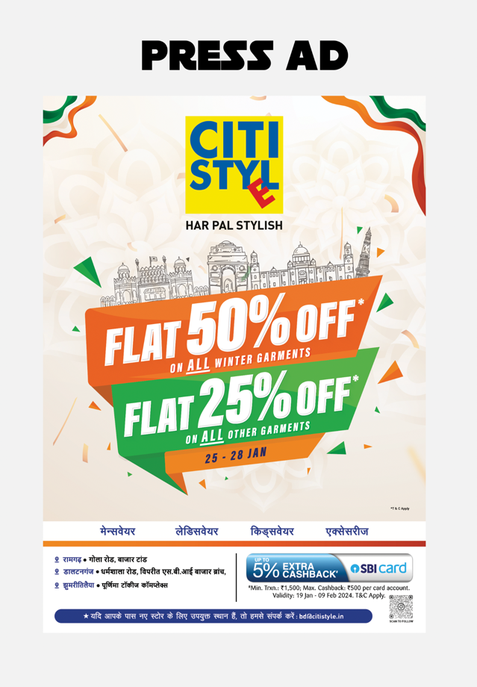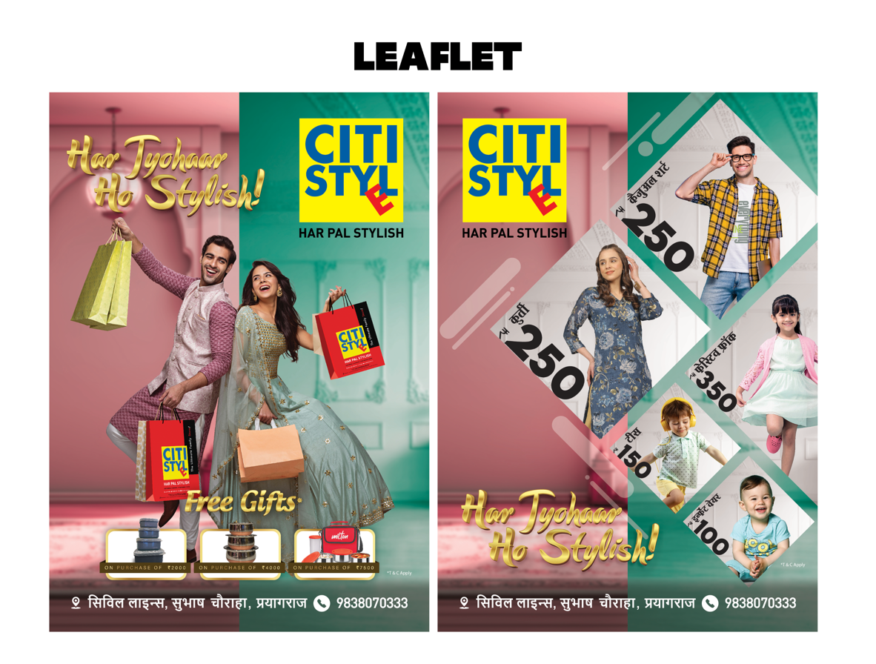

* Drive more digital engagement levels on platforms such as Instagram, Facebook, and YouTube
* Enhance more brand consistency not only in states such as West Bengal, Odisha, UP, and Jharkhand, it’s time to experience other states market also.

Additionally, expert design will aid in facilitating enhanced storytelling of affordability, product excellence, and fashion, which are the foundational brand pillars of Citi Style.

*B. Revisiting and Revising the Marketing Budget*

Recommendation: Go over last year's marketing budget and create a revised allocation plan that captures shifting business requirements and growth aspirations. Additional funds will be allocated specifically to:

* Digital marketing and influencer collaborations
* Outdoor advertising in seasons of high demand
* Visual merchandising and décor enhancement within stores
* Professional content production (photoshoots, videography)

Rationale: The existing budgeting may not be adequate to take on cutthroat marketing by the likes of competitors Zudio, Style Bazaar, or V-Mart. A budget realignment with ROI-driven objectives will guarantee that each rupee invested in marketing fuels awareness, traffic, and eventually revenue.

A cost-benefit analysis of previous campaigns can assist in determining which mediums work best (e.g., WhatsApp marketing vs. print vs. hoardings), and the budget can accordingly be reallocated to focus on high-performing mediums. This will render marketing more data-driven, focused, and effective.

*C. Maintaining and Promoting the "Rs. 100 Starting Price" Tagline*

Recommendation: Prominently feature Citi Style's differential price positioning through a well-designed campaign based on the catchy tagline:

"Style Starts at Just Rs. 100!"

This message must be highlighted in:

* Window displays
* Newspaper advertisements
* Social media content and feeds
* Hoardings and digital displays
* Google and Meta Ads

Reasoning: Price is still the strongest customer attractant, particularly in Tier-II and Tier-III cities. Survey data indicated that 55% of customers patronized Citi Style because it was affordable. Enforcing the low-price perception—without sacrificing on product attractiveness—will drive existing price-conscious customers to stay and bring in new customers.

Second, this ad makes Citi Style stand out from mid-market competitors and creates immediate brand recognition. Repeated strategically across channels will also cement Citi Style's position as the most affordable fashion destination.

**7.7 Summary**

The above recommendations are in consonance with Citi Style's key project goals:

Increase Sales Revenue: Through best-in-class inventory, phygital interaction, targeted marketing, and tactical promotions.

Enhance Customer Satisfaction: Through enhanced service quality, one-on-one communication, and reward benefits.

Streamline Operations: Through adoption of technology, streamlined sales processes, and improved-trained personnel.

Phased introduction, underpinned by effective leadership and timely feedback loops, will be crucial to delivering these strategies into tangible performance benefits. Citi Style can strengthen its role as a value fashion market leader by embracing these new, customer-centric methodologies.

**Chapter 8: Implications**

**8.1 Introduction**

The chapter discusses the implications of the study findings from a theoretical and practical standpoint. The main aim is to discuss how data gathered and analysed during the study help in the overall academic understanding of the performance of retail sales and how Citi Style can leverage such findings in developing actionable strategies for enhancing operational effectiveness, customer satisfaction, and revenue increase. Implications are especially important in the context of the project's primary goals: a 20% sales revenue growth, building relationships with customers, and optimizing sales operations.

**8.2 Theoretical Implications**

*8.2.1 Alignment with Existing Retail Sales Literature*

The results of the present study confirm several of the established theories of the retail and consumer behavior literature. For example, the role of promotional campaigns and festival-based marketing in increasing sales is consistent with Kotler and Keller (2016), who highlighted the critical role of temporal stimuli such as seasons and festivals in influencing consumer purchasing behaviour.

Also, the predominance of price as the compelling force for shopping at Citi Style is consistent with Maslow's hierarchy of needs, where the fundamental economic access underlies consumer choices in the lower-middle and middle-income classes. The results also resonate with research by Sharma & Jaiswal (2017) and Das (2020), which highlighted price sensitivity and value-for-money as principal drivers in the success of retail chains such as V-Mart and Bazaar Kolkata.

*8.2.2 Extension to Rural and Sub-Urban Retailing Theories*

This study also adds to newer retail theories targeting sub-urban and rural Indian markets. Citi Style's success in semi-urban and smaller towns corroborates the new theory that rural and Tier-II/III markets are not passive consumers anymore but are actually driving consumption patterns. The success of digital interaction instruments such as WhatsApp catalogs and merged shopping experiences for Gen Z in rural areas defies traditional urban-biased digital uptake paradigms and broadens the theoretical debate surrounding omnichannel retailing.

*8.2.3 Technological Adaptation and Customer Loyalty Programs Insights*

Technologically, the research indicates that although physical retailing is still the lead, there is increasing demand for "phygital" fusion — a blurring of digital and physical experiences. This supports recent literature arguing in favor of mid-size retailers undertaking investment in light CRM and marketing technologies instead of full-scale e-commerce transformations, especially for those geographies with infrastructural constraints.

In addition, hypothesis testing indicated that loyalty programs correlated positively with repeat purchasing. This contributes further to the expanding body of evidence highlighting the importance of individualized marketing and data-driven loyalty efforts within retail — an area primarily ruled by e-commerce businesses but now more and more applicable to offline retailing business as well.

*8.2.4 Contribution to Strategic Retail Management Literature*

The integrated perspective of the study—focusing on operational effectiveness, customer satisfaction, inventory management, and marketing—makes it part of the integrated strategic management literature. The results of cross-comparing staff interviews, customer opinions, and sales figures give a replicable model for other similar retail chains operating in emerging markets. The findings also necessitate a more interdisciplinary treatment in retail studies in the future, drawing from marketing, operations, human resource management, and IT disciplines.

**8.3 Practical Implications**

*8.3.1 Marketing Strategy Improvements*

The most immediate practical implication is the pressing necessity to improve and refine marketing strategies. According to the study, promotional activities like Chaitra Sale, Monsoon Sale, and Winter Clearance campaigns have a strong impact on foot traffic and sales. But competitors such as Zudio, Yousta, and Pantaloons are conducting much more frequent and attention-grabbing marketing campaigns, taking advantage of high brand equity and aggressive budget shifts.

Citi Style needs to spend money on marketing staff — excellent graphic designers — and current budgeting to be able to compete. The point here is not necessarily about marketing more, but doing it better, reaching the right customers with great graphics and value points, and being consistent offline as well as online.

*8.3.2 Customer Engagement and Retention Programs*

The minimal response of current loyalty programs (just 5% mentioned loyalty as a leading reason) indicates a disconnect in customer retention mechanisms. This necessitates an overhaul of Citi Style's CRM strategy. Adding personalized offers, birthday/anniversary offers, and a points-based reward system available through mobile numbers or applications can drive repeat business.

Additionally, integrating real-time feedback from digital surveys and Google Reviews in decision-making would improve customer-centricity. The launch of shop-and-get-gift programs, where customers are given a trolley bag at a low price on big-ticket spending, was effective and needs to be made a normal campaign strategy.

*8.3.3 Technological Integration and Digital Expansion*

The increasing popularity among younger shoppers for WhatsApp-based catalogs, online checks of inventory, and online booking offers a significant opportunity. Although full-fledged e-commerce is perhaps not an option in all markets Citi Style has a presence in, implementing simple tech integrations such as:

* WhatsApp for Business for campaign notifications.
* Mobile-optimized digital product catalogue.
* Online reservation with pickup in-store.

… can bridge the gap between offline trust and online convenience. They are low-impact but affordable and meet both customer demand and Citi Style's operational range.

*8.3.4 Improvements to Inventory Management*

The findings indicate that product category demand shifts by season and by customer demographics. Women's and men's wear lead in sales, and accessories and footwear are generally impulse purchases. Hence, Citi Style ought to implement a more dynamic and localized inventory policy:

* Seasonal forecast based on historical sales patterns.
* Periodic clearance sales to avoid the buildup of dead stock.
* Cross-merchandising of accessories with top-selling categories.
* Monitoring of inventories in real-time through easy-to-use ERP systems to reduce overstocking or understocking.

This practical transition would minimize waste of operations, maximize shelf space, and enhance customer shopping experience.

*8.3.5 Sales Staff Development and Training*

Customer feedback from Google Reviews and store surveys highlighted employees' behavior and product knowledge as the most important drivers of in-store satisfaction. In this regard, Citi Style can introduce formal training programs on:

* Customer handling and communication skills.
* Product upselling skills.
* Real-time resolution of problems.

A feedback loop mechanism wherein store managers discuss performance metrics and customer reviews on a weekly basis can also assist in identifying areas of improvement and motivating accountability.

*8.3.6 Budgeting and Strategic Resource Allocation*

One key discovery was low budget allocation to marketing and digital interaction. In contrast to competitors who execute successive promotions, Citi Style is seen to be conservative on marketing frequency and investment. A strategic adjustment of the previous year's budget and resultant reallocation permitting higher marketing expenditure — particularly during high-seasons and store anniversary dates — can generate big ROI. Such choices should be guided by analysis of campaign ROI and acquisition costs.

*8.3.7 Maintaining Competitive Advantage through Price Strategy*

The point of difference of Citi Style — providing looks beginning at ₹100 — is a big crowd raiser and differentiator. This price strategy needs to be boldly emphasized in every campaign. The success of this strategy was depicted in both survey and Google Review metrics. Promotional banners, social media advertising, and in-shop displays need to reiterate this USP to stay top-of-mind in the value-minded consumer segment.

*8.3.8 Regional Customization and Localization*

The analysis noted regional differences in customer choices and review sentiments. For instance:

* Ethnic wear and kidswear are more popular in Odisha and Jharkhand.
* Festive-centric shopping is more predominant in West Bengal.
* UP has more casual wear and weekend shopping with higher activity.

Citi Style can leverage these observations to create region-specific stock planning, locally translated marketing content, and culturally appropriate promotions. This localization builds relevance and increases the overall brand affinity with people.

8.4 Conclusion

The findings of this study have widespread and profound implications. At a theoretical level, it contributes to our understanding of how value fashion retailing can be modified for sub-urban and rural economies, incorporated with lightweight technology, and cultivated in terms of customer loyalty beyond price. At a practical level, it presents Citi Style with a clear guide — based on facts — to redefine its marketing, operational, and engagement practices.

If applied with consistency and flexibility, these implications might bring Citi Style to not only achieve but exceed its quarterly sales targets, increase customer satisfaction, and become a top player in affordable fashion retail in East and North India.

**Chapter 9: Conclusion**

**9.1 Introduction**

The current research, "Sales Performance Enhancement of Retail Company: Citi Style," was conducted with the sole aim of finding and executing strategies to raise the retail performance of the company across its multiple stores located in West Bengal, Uttar Pradesh, Jharkhand, and Odisha. The study delved into various aspects of sales operations, customer satisfaction, and marketing strategies to gain a thorough grasp of the contemporary performance scenario and suggest actionable directions for sustainable growth. This chapter presents the major findings, considers the project aims, talks about the wider implications of the study, and offers final observations on the retail strategy future of Citi Style.

**9.2 Restatement of Objectives**

The key targets established at the beginning of this study were:

* Enhancing sales revenue by 20% within the next operational quarter.
* Improved customer interaction and enhancing the level of satisfaction.
* Simplifying inventory, human resource, and operational procedures.
* Improving the overall visibility and loyalty of the brand across regions.
* Using data-driven decision-making for promoting business growth.

These aims underpinned the data gathering, examination, and strategic proposals laid out across the report. The conclusion returns to these goals and considers how far the research has facilitated implementable advance on each.

**9.3 Summary of Key Findings**

From the comprehensive examination of customer questionnaires, staff interviews, Google Reviews, and sales data, a number of key insights were revealed:

* Price Sensitivity as the Key Driver: The most powerful driver of customer purchases at Citi Style is price affordability. The company's reputation as a value brand is deeply embedded in consumer attitudes and is highlighted by the slogan "Style starts from ₹100 onwards."
* Effect of Promotional Events: The Chaitra Sale, Monsoon Sales, and Winter Clearance sales campaigns have witnessed extremely high spikes in sales, illustrating the significance of time-limited promotional initiatives.
* Mixed Customer Satisfaction: While customers are fond of pricing and variety, Google Reviews' feedback proves inconsistency in employees' conduct, availability of products, and billing procedure efficiency.
* Regional Buying Behavior: Regional preferences are different, with ethnic wear and kidswear being more preferred in Odisha and Jharkhand, and casual wear experiencing greater traction in Uttar Pradesh. West Bengal is most sensitive to festival-themed promotions.
* Underutilized Digital and Loyalty Solutions: Few customers utilize digital catalogs or loyalty schemes. Nonetheless, online stock assessments and shopping applications via WhatsApp are gaining traction among younger consumers.
* Training Needs for Sales Teams: Salespersons play a crucial role in defining the store experience. The level of ad hoc and targeted training programs is reflected in the inconsistent customer service.

These were confirmed by applying statistical software like SPSS and Excel, enabling correlation analysis, hypothesis testing, and trend projection.

**9.4 Alignment with Project Aims**

The conclusions collected over the course of the research present a strong foundation for realizing the primary goals:

1. Sales Revenue Growth:

* Promotional activities along with focused regional promotion and improved inventory alignment present obvious avenues for realizing a 20% growth ambition.
* Recommended budgeting and marketing graphics can enhance campaign effectiveness, driving increased footfall and conversion rates.

1. Better Customer Satisfaction:

* Organized customer loyalty schemes, shopping through WhatsApp, and better in-store service are the mainstay of retaining existing customers and gaining new ones.
* Staff training, return policies, and in-store hygiene will lead to direct improvements in the customer experience.

1. Operational Efficiency:

* Application of lightweight ERP solutions, dynamic inventory planning, and region-specific stocking policies will streamline operations and lower overheads.
* Automating sales reporting and CRM integration will enable managers to make quicker, data-based decisions.

1. Brand Positioning:

* Keeping and aggressively pushing the ₹100 price-tag concept, backed by powerful visuals and localized communications, will emphasize Citi Style's brand identity as the affordable fashion leader of Tier-II and Tier-III cities.

**9.5 Final Reflections on Methodology**

The study employed a mixed-methods design, utilizing both quantitative and qualitative data sources in an attempt to understand Citi Style's performance from every angle. Customer questionnaires (n=500), worker interviews (n=25), and review mining on channels such as Google Reviews provided varied viewpoints.

Statistical verification was carried out using SPSS, such as hypothesis testing of the effect of loyalty schemes on repeat purchases, which proved to be statistically significant (p < 0.05). In addition, graphical tools utilized Microsoft Excel to perform in-depth analysis of monthly sales trends, and visualization depicted the results for ease of reading.

The data triangulation helped ensure that findings not only held true but were also generalizable across departments — from operations to inventory and HR to marketing. This strong methodology enhances the validity and reliability of the findings made.

**9.6 Study Limitations**

Though the study yields important findings, certain limitations need to be noted:

* Geographic Restriction: The research was only conducted on the four states of West Bengal, UP, Jharkhand, and Odisha, which, while heterogeneous, do not account for the entire country's retailing base.
* Time Restriction: The data considered is largely of the last 12 months. Seasonal or outside interference (e.g., supply chain issues) could have affected some trends.
* Digital Footprint Analysis: Offline behavior was primarily evaluated in the research. Further digging into digital engagement metrics (e.g., click-through rates on WhatsApp catalogs or SMS campaigns) would add more richness to the results.
* Sampling Bias: Effort has been made to segment the survey sample, but overrepresentation of some customer groups (e.g., middle-income families) may bias some inferences.

Nonetheless, the research is still exhaustive and directionally correct, with pragmatic value for Citi Style management.

**9.7 Contribution to Business and Research**

The research contributes to the business and academic world by:

Academic Contribution:

* Proves prevailing theory in pricing strategy and customer interaction in the Indian value retail market.
* Provides empirical data for developing discourse on regional retailing behavior and digital take-up in semi-urban economies.
* Presents a research model integrating survey, review analysis, and sales data — potentially applicable for use in other retailers.

Business Contribution:

* Delivers a turnkey roadmap for future growth of Citi Style.
* Pinpoints low-cost, high-impact initiatives such as targeted promotions, geo-located campaigns, and inventory stocking optimization.
* Suggests adoption of digital solutions attuned to non-e-commerce-first consumers to close the offline and online experience gap.

**9.8 Future Research Recommendations**

Future research can build on this study by:

* Conducting a longitudinal study to see how campaign enhancements and CRM tool adoption affect the business in the long term.
* Comparative analysis between Citi Style and peers such as Zudio, Yousta, and V-Mart to identify relative drivers of performance.
* Addition of staff motivation, staff turnover, and the contribution of internal culture towards customer satisfaction analysis.

Furthermore, future research could incorporate machine learning for forecasting sales or analysing sentiment within customer reviews, paving the way for predictive analytics in mid-size retail.

**9.9 Conclusion**

Finally, through this study, the essential drivers, challenges, and opportunities of Citi Style's retail infrastructure have indeed been unwrapped. The implications of these findings emphasize the potential of focused marketing, operational flexibility, and technology integration in the current retail environment — particularly for companies doing business in cost-conscious and diverse markets.

Citi Style, with its brand strength and low price, stands to gain from its strengths and take care of its weaknesses. With the adoption of the proposals laid out — from salespeople training and inventory redesign to electronic communication and local campaign localization — the brand can succeed in meeting its target of 20% sales growth and transform itself into a customer-focused, effective, and competitive force in the retail industry.

**Bibliography:**

* India Brand Equity Foundation (IBEF). (2023). Retail Industry in India. https://www.ibef.org/industry/retail-india
* Deloitte. (2022). Indian Retail Sector Report. https://www2.deloitte.com/in/en/pages/consumer-business/articles/retail-sector.html
* Statista. (2024). Apparel retail in India. https://www.statista.com/statistics/india-retail-apparel
* Microsoft Excel. (2019). Microsoft Corporation.
* Adobe Illustrator to resize the images (for presentation)
* Google Reviews data for Citi Style stores (2024–2025), collected via public access through Google Maps.
* Citi Style Official Website and Social Media Pages (Facebook, Instagram). Accessed 2025.

**Appendices:**

* A sample customer questionnaire
* A sample interview transcript with a store manager
* Example tables and charts used in your analysis

You can make it more tailored according to the actual data you have collected.

Appendix A: Customer Questionnaire Sample

Title: "Customer Feedback and Buying Behaviour Survey – Citi Style"

Purpose: To obtain information about customer likes, satisfaction, and buying behaviour concerning Citi Style retail stores.

Instructions: Please answer the following questions. Your responses will be held in confidence and used solely for academic purposes.

*Section 1: Demographic Information*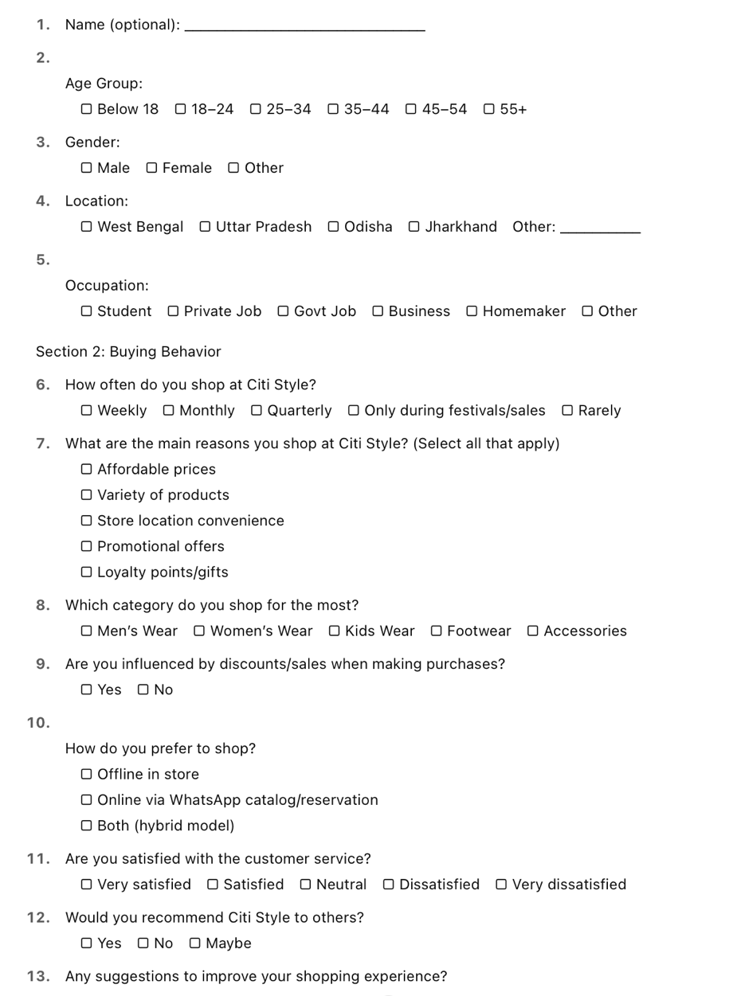

Appendix B: Sample Interview Transcript (Store Manager – Jharkhand Branch)

Interviewer: "Can you share with us what changes you've seen in customer behaviour over the past year?"

Manager: "Customers are getting more deal-aware. They eagerly wait for our festive campaigns such as Chaitra Sale or Monsoon Offers. They also inquire more regarding WhatsApp catalogue updates, particularly Gen Z customers."

Interviewer: "What impact do weekend sales have on your store traffic?"

Manager: "There is generally a 15–20% boost in footfalls. Particularly if offered with free gift offers such as trolleys or bags. Customers appreciate visible pricing like 'Starts at ₹100' – it actually works."

Interviewer: "Operational issues?"

Manager: "We require tighter backend coordination, particularly in inventory management. And yes, marketing material can be enhanced — we don't have sufficient graphics support to make good promos."

Interviewer: "Improvement suggestions in overall sales?"

Manager: "Increased digital integration, improved visual merchandising, and budgeting for ongoing marketing — these would actually be able to drive expansion."

* Appendix C: Ancillary Tables and Charts  
    
  Table 1: Shopping Frequency of Customers

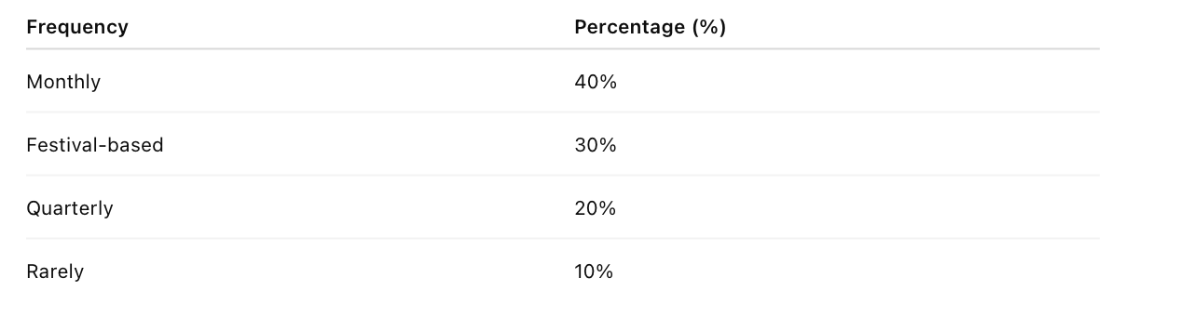

* Table 2: Customers' Category Preference

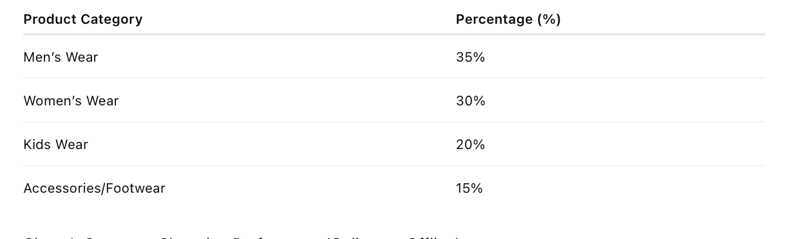

Ultimately I can conclude This project provides an overall analysis and strategic plan that will help improve the sales performance, customer satisfaction, and operational effectiveness of Citi Style in its retail branches.